Phystech.International Olympiad in Biology
2020/21 academic year
Online qualifying stage

Tasks for graduating level

The Olympiad tasks are divided into three parts:
Part A: Tasks with one correct answer (20 tasks, 27 points in total)
Part B: Multiple Choice Questions (10 tasks, 30 points in total)
Part C: Matching Questions (7 tasks, 35 points in total)
Total: 92 points

Part A: Tasks with one correct answer

In all the tasks of this part, there is a condition at the beginning, and then four answer options (under the letters from A to D). Participants need to determine which one of the answer options is correct (fits the wording of the task). Each task can have only one correct answer. For each question, the number of points for the correct answer is indicated: there are two costs - 1 point each and 2 points each.

Grading system:
For each correct answer - 1 or 2 points
For each wrong answer - 0 points

Task 1 (ID 2) – 1 point
Common part of the question for all variants:
Secondary growth of the stem caused by the activity of the lateral meristem – cambium is typical for:

Variant 1:
- mosses, gymnosperms, angiosperms;
- monocotyledonous angiosperms, gymnosperms;
- ferns, dicotyledonous angiosperms;
- gymnosperms and dicotyledons angiosperms;

Variant 2:
- mosses and angiosperms;
- gymnosperms and dicotyledons angiosperms;
- monocotyledonous and dicotyledonous angiosperms;
- ferns, gymnosperms;

Variant 3:
- gymnosperms and dicotyledons angiosperms;
- mosses and gymnosperms;
- monocotyledonous angiosperms, gymnosperms;
- ferns, monocotyledonous angiosperms;

Task 2 (ID 3) – 1 point
Common part of the question for all variants:
The picture below is a cross-sectional view of a young linden branch (Tilia sp.) under a microscope.
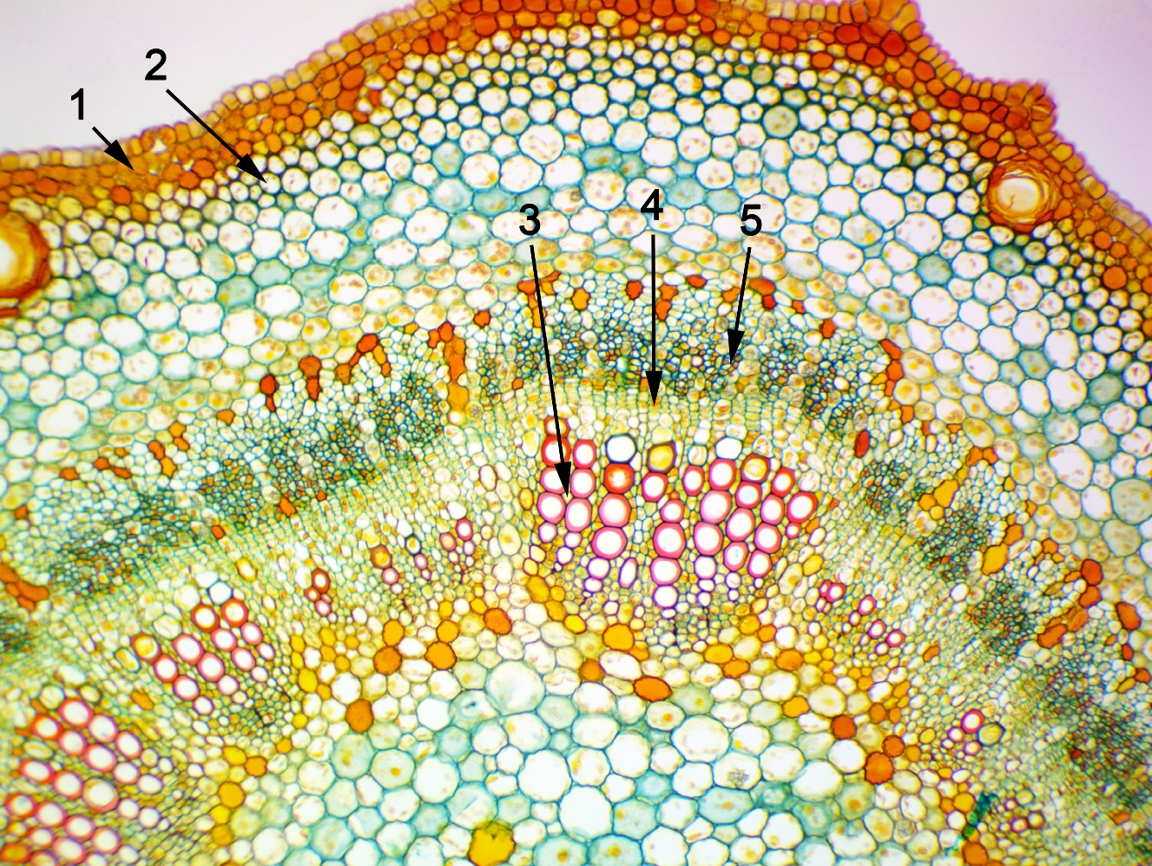
What plant tissues are indicated by numbers? Choose the right combination of numbers and plant tissue names:

Variant 1:
- 1 – epidermis, 2 – chlorenchyme, 3 – xylem, 4 – cambium, 5 – phloem;
- 1 – periderm, 2 – collenchyma, 3 – phloem, 4 – cambium, 5 – xylem;
- 1 – epidermis, 2 – collenchyma, 3 – xylem, 4 – pericycle, 5 – phloem;
- 1 – periderm, 2 – collenchyma, 3 – xylem, 4 – cambium, 5 – phloem;

Variant 2:
- 1 – periderm, 2 – collenchyma, 3 – xylem, 4 – cambium, 5 – phloem;
- 1 – periderm, 2 – sclerenchyma, 3 – phloem, 4 – cambium, 5 – xylem;
- 1 – epidermis, 2 – collenchyma, 3 – phloem, 4 – cambium, 5 – xylem;
- 1 – periderm, 2 – sclerenchyma, 3 – xylem, 4 – cambium, 5 – phloem;

Variant 3:
- 1 – epidermis, 2 – collenchyma, 3 – phloem, 4 – cambium, 5 – xylem;
- 1 – periderm, 2 – sclerenchyma, 3 – xylem, 4 – cambium, 5 – phloem;
- 1 – periderm, 2 – collenchyma, 3 – xylem, 4 – cambium, 5 – phloem;
- 1 – epidermis, 2 – chlorenchyma, 3 – phloem, 4 – pericycle, 5 – xylem;

Task 3 (ID 4) – 2 points
Common part of the question for all variants:
The color, structure and other features of the flowers of angiosperms are closely related to the characteristics of the animals pollinating them. Match the following plant flower descriptions (1 to 5) with the most likely pollinator for a given flower.
1. Flowers are white, open at night, have an intense odor, nectar is hidden in long dense tubes;
2. Flowers often with ultraviolet dyed pattern, open in the daytime, with a pleasant aroma;
3. The flowers are large and rough, bright red, open in the daytime, odorless, but with a lot of nectar;
4. The flowers are large, open at night, with an intense aroma and a lot of nectar;
5. Flowers are reddish-brown, no nectar, with the smell of decaying meat.

Variant 1:
- 1 – bats, 2 – bees, 3 – flies, 4 – moths, 5 – birds;
- 1 – moths, 2 – birds, 3 – bees, 4 – bats, 5 – flies;
- 1 – bees, 2 – moths, 3 – birds, 4 – bats, 5 – flies;
- 1 – moths, 2 – bees, 3 – birds, 4 – bats, 5 – flies;

Variant 2:
- 1 – moths, 2 – flies, 3 – birds, 4 – bats, 5 – bees;
- 1 – moths, 2 – bees, 3 – birds, 4 – bats, 5 – flies;
- 1 – bats, 2 – birds, 3 – bees, 4 – moths, 5 – flies;
- 1 – birds, 2 – bats, 3 – flies, 4 – moths, 5 – bees;

Variant 3:
- 1 – moths, 2 – bees, 3 – birds, 4 – bats, 5 – flies;
- 1 – bats, 2 – bees, 3 – flies, 4 – moths, 5 – birds;
- 1 – bats, 2 – flies, 3 – birds, 4 – moths, 5 – bees;
- 1 – bats, 2 – birds, 3 – bees, 4 – moths, 5 – flies;

Task 4 (ID 6) – 1 point
Common part of the question for all variants:
The figure below shows schematic diagrams of the circulatory system in various groups of vertebrates.
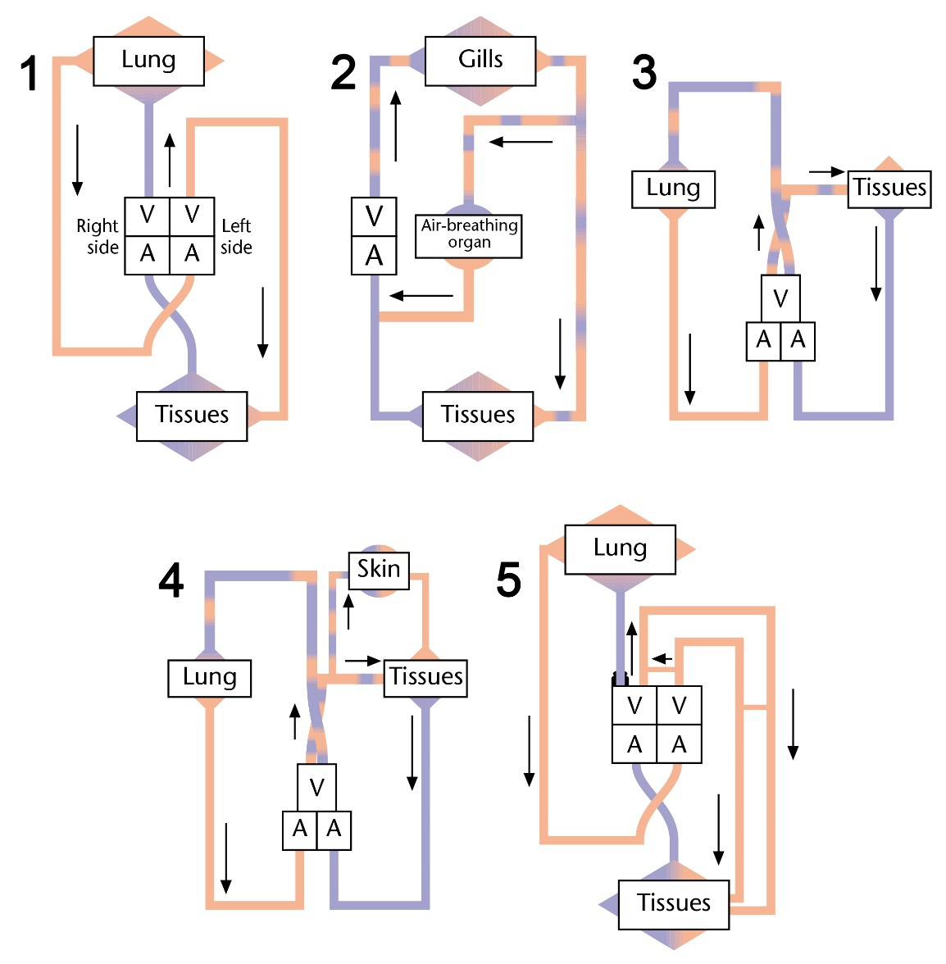
Description: A = atrium, V = ventricle. Inspect diagrams, and determine which groups of vertebrates belongs each circulatory system:

Variant 1:
- 1 – crocodiles, 2 – sharks, 3 – snakes, lizards, turtles, 4 – urodele amphibian, 5 – birds and mammals;
- 1 – birds and mammals, 2 – anuran amphibian, 3 – snakes, lizards, turtles, 4 – fish that can breathe through the skin, 5 – crocodiles;
- 1 – crocodiles, 2 – air-breathing fish, 3 – urodele amphibian, 4 – snakes, lizards, turtles, 5 – birds and mammals;
- 1 – birds and mammals, 2 – air-breathing fish, 3 – snakes, lizards, turtles, 4 – urodele amphibian, 5 – crocodiles;

Variant 2:
- 1 – birds and mammals, 2 – sharks, 3 – urodele amphibian, 4 – crocodiles, 5 – snakes, lizards, turtles;
- 1 – birds and mammals, 2 – snakes, lizards, turtles, 3 – crocodiles, 4 – urodele amphibian, 5 – air-breathing fish;
- 1 – birds and mammals, 2 – air-breathing fish, 3 – snakes, lizards, turtles, 4 – urodele amphibian, 5 – crocodiles;
- 1 – crocodiles, 2 – air-breathing fish, 3 – urodele amphibian, 4 – snakes, lizards, turtles, 5 – birds and mammals;

Variant 3:
- 1 – birds and mammals, 2 – air-breathing fish, 3 – snakes, lizards, turtles, 4 – urodele amphibian, 5 – crocodiles;
- 1 – crocodiles, 2 – air-breathing fish, 3 – snakes, lizards, turtles, 4 – urodele amphibian, 5 – birds and mammals;
- 1 – birds and mammals, 2 – anuran amphibian, 3 – snakes, lizards, turtles, 4 – fish that can breathe through the skin, 5 – crocodiles;
- 1 – birds and mammals, 2 – snakes, lizards, turtles, 3 – crocodiles, 4 – urodele amphibian, 5 – air-breathing fish;

Task 5 (ID 7) – 1 point
Common part of the question for all variants:
Given below are data on the breathing rate, heart rate and body temperature of four different mammals, A to D.
Animals | Breathing rate  (inhalations/min) | Breathing rate  (inhalations/min) | Body temperature  (°C)
A | 160 | 500 | 36,5
B | 15 | 40 | 37,2
C | 28 | 190 | 38,2
D | 8 | 28 | 35,9
Rank animals A to D in descending order for surface area per unit volume of the body and in descending order for total volume of blood in the body:

Variant 1:
- surface area per unit volume of the body D > B > C > A, total volume of blood in the body A > C > B > D;
- surface area per unit volume of the body C > B > A > D, total volume of blood in the body е D > A > B > C;
- surface area per unit volume of the body A > C > B > D, total volume of blood in the body D > B > C > A;
- surface area per unit volume of the body D > A > B > C, total volume of blood in the body C > B > A > D;

Variant 2:
- surface area per unit volume of the body A > C > B > D, total volume of blood in the body D > B > C > A;
- surface area per unit volume of the body A > C > B > D, total volume of blood in the body A > C > B > D;
- surface area per unit volume of the body C > B > A > D, total volume of blood in the body е D > A > B > C;
- surface area per unit volume of the body C > B > A > D, total volume of blood in the body C > B > A > D;

Variant 3:
- surface area per unit volume of the body D > B > C > A, total volume of blood in the body D > B > C > A;
- surface area per unit volume of the body A > C > B > D, total volume of blood in the body D > B > C > A;
- surface area per unit volume of the body D > A > B > C, total volume of blood in the body C > B > A > D;
- surface area per unit volume of the body D > A > B > C, total volume of blood in the body D > A > B > C;

Task 6 (ID 8) – 2 points
Common part of the question for all variants:
Honeybees can see in polarized light, including in the ultraviolet region of the spectrum. This allows them to use the "solar compass" for navigation and measure the angle between the direction of flight and the direction to the sun. Having discovered a new food source, a honey bee can remember the way to it by two parameters (1) the angle between the direction from the hive to the food source and the direction from the hive to the sun, (2) the distance from the hive to the food source (by visual signs). Back in the hive, the bee can share this information with other bees through a "wagging dance," which is a ritual in which it makes circular movements (example below) along the vertical walls of the hive. The section of the dance trajectory in which the bee rapidly vibrates its abdomen is marked with a wavy line. The angle between the vertical axis, which is set by gravity, and the "wagging" section of the dance tells the other bees the angle towards the food source (relative to the hive and the direction to the sun), and the duration of the "wagging" section of the dance is proportional to the distance from the hive.
The figure shows a diagram of a hive and eight food sources located on different sides of it.
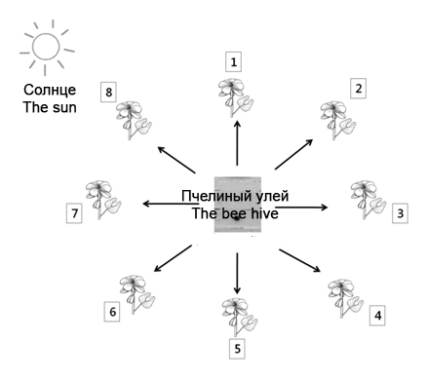
To show the path to the first food source, the scout bee performs the following "wagging dance" (the dotted line indicates the gravitational axis):
Compare the wagging dances of the bees in the pictures below with the numbers of the food sources they direct other bees to:

Variant 1:
- A-4, B-2, C-8, D-5;
- A-8, B-2, C-4, D-5;
- A-1, B-3, C-5, D-2;
- A-4, B-6, C-8, D-5;

Variant 2:
- A-4, B-2, C-8, D-1;
- A-8, B-6, C-4, D-5;
- A-4, B-6, C-8, D-5;
- A-3, B-5, C-7, D-4;

Variant 3:
- A-4, B-2, C-8, D-5;
- A-4, B-6, C-8, D-5;
- A-5, B-7, C-1, D-6;
- A-3, B-5, C-7, D-4;

Task 7 (ID 10) – 1 point
Common part of the question for all variants:
The volume of blood pumped by each ventricle during a beat is known as systolic volume. If the systolic volume is multiplied by the number of beats per minute, the resulting value is the cardiac cost.
Cardiac cost = systolic volume * cardiac frequency

Variant 1:
Which is the cardiac cost (volume of blood pumped by each ventricle in a minute) of an adult person in rest whose heart beats 72 times per minute and pumps 70 milliliters of blood in each contraction?
  - 3 l/min;
  - 5 l/min;
  - 10 l/min;
  - 50 l/min;

Variant 2:
Which is the cardiac cost (volume of blood pumped by each ventricle in a minute) of an adult person in rest whose heart beats 55 times per minute and pumps 90 milliliters of blood in each contraction?
  - 3 l/min;
  - 5 l/min;
  - 10 l/min;
  - 50 l/min;

Variant 3:
Which is the cardiac cost (volume of blood pumped by each ventricle in a minute) of an adult person in rest whose heart beats 67 times per minute and pumps 90 milliliters of blood in each contraction?
  - 0,6 l/min;
  - 3 l/min;
  - 6 l/min;
  - 60 l/min;

Task 8 (ID 11) – 1 point
Common part of the question for all variants:
Mitochondria are the most important cell organelles that oxidize carbohydrates and lipids and synthesize ATP molecules. Human mitochondria contain their own DNA with 37 genes. In this case, mitochondria are inherited only through the maternal line - along with the egg. Mitochondria from the sperm do not enter the egg during fertilization. Therefore, mutations in the genes of the mother's mitochondrial DNA can lead to severe hereditary diseases or early fetal death.
The “three parents” method (mitochondrial replacement therapy) eliminates the effect of mutations in the mother's mitochondrial DNA genes. In this method, the zygote is obtained during artificial insemination and contains the genetic material of the father and mother, and the mitochondria are provided by the third donor parent. From the list of manipulations below, select those that allow doctors to obtain healthy zygotes "from three parents":
1) The nucleus of the mother's egg is transferred into the donor's egg (with normal mitochondria), which does not contain the nucleus, and then the egg is fertilized by the father's sperm;
2) The nucleus of the zygote, obtained by fertilizing the mother's egg with the father's sperm, is transferred to the donor zygote (with normal mitochondria) that does not contain the nucleus;
3) The nucleus of the sperm is transferred to the mother's egg, along with the father's mitochondria;
4) One mitochondrion from the donor's egg (with normal mitochondria) is transferred to the mother's egg, and then fertilization with the father's sperm takes place

Variant 1:
- only 2;
- 1 or 2;
- 2 or 3;
- 1 or 4;

Variant 2:
- only 1;
- 3 or 4;
- 1 or 2;
- 2 or 4;

Variant 3:
- 1 or 2;
- only 1;
- only 4;
- 2 or 3;

Task 9 (ID 12) – 2 points
Common part of the question for all variants:
The human retina contains two types of photoreceptor cells: rod cells, which are responsible for monochromatic vision, and cone cells, which provide color vision. Photoreceptor cells are in contact with the dendrites of bipolar cells, which carry out primary processing of information, and those are in contact with ganglionic cells that conduct nerve impulses to the visual centers of the brain. Below is a diagram of the organization of contacts of all the cells described above for rods and cones separately.
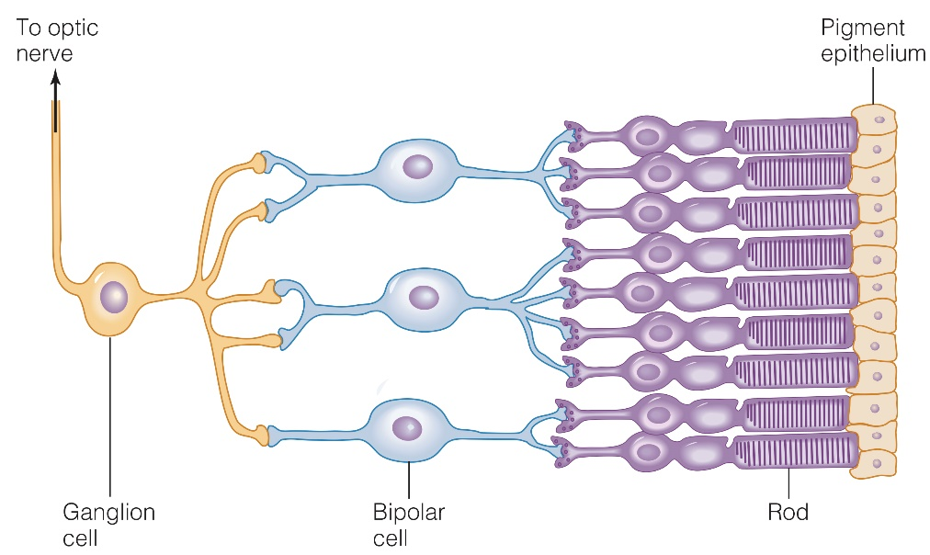
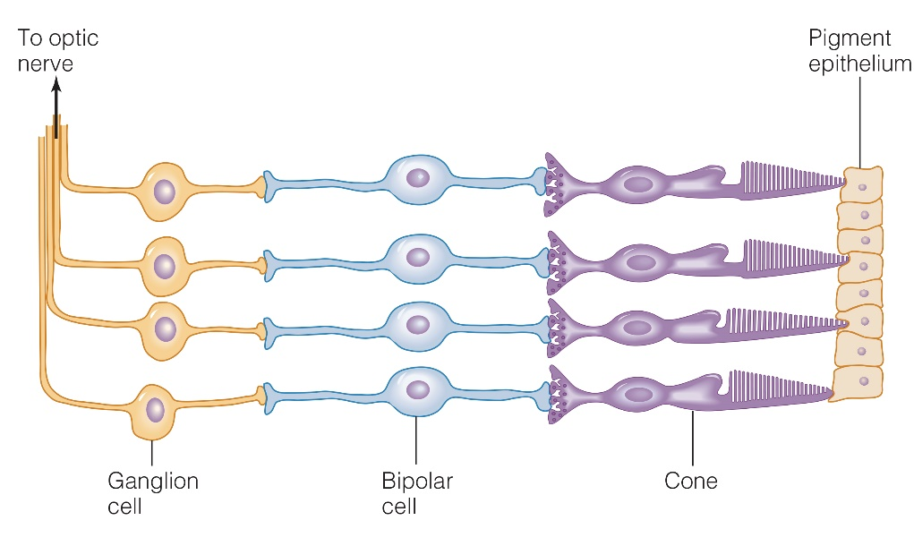
Which of the following statements are correct:
1. The flux of photons of light on the diagrams passes from left to right, therefore, some of the rods and cones are shielded by the bodies of ganglionic and bipolar cells.
2. The flux of photons of light on the diagrams passes from right to left, so the color captured by the photoreceptors depends on the color of the pigment cell through which the light passed.
3. Bipolar cells are in contact with multiple rod cells, but each bipolar cell is in contact with one cone cell.
4. Each ganglion cell transmits impulses to the visual centers of the brain from a large number of rod cells that form an extensive visual field, but from one or more cone cells.
5. Human color vision has a higher resolution (detail) than monochromatic vision.

Variant 1:
- 3, 4, 5;
- 1, 3, 4;
- 2, 3, 5;
- 1, 2, 3, 4;

Variant 2:
- 2, 3, 4;
- 2, 3, 4, 5;
- 1, 2, 3;
- 3, 4, 5;

Variant 3:
- 1, 3, 5;
- 1, 2, 3;
- 3, 4, 5;
- 1, 2, 3, 4;

Task 10 (ID 14) – 1 point
Common part of the question for all variants:
Mitochondria are the primary site in cells for the metabolism of long-chain fatty acids, and use a process called beta-oxidation. One cycle of beta-oxidation of a fatty acid, which has been prior activated to a coenzyme A (CoA) ester, is shown below:
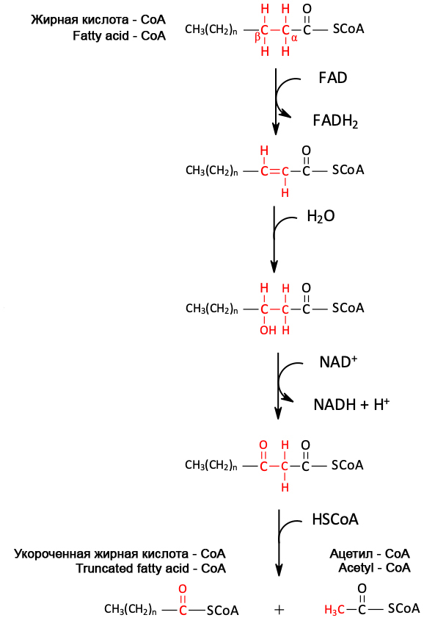
Variant 1:
Based on this diagram, how many cycles of the pathway would be needed for complete beta-oxidation of stearic acid (C_{18:0})?
  - 7;
  - 8;
  - 9;
  - 10;

Variant 2:
Based on this diagram, how many cycles of the pathway would be needed for complete beta-oxidation of palmitic acid (C_{16:0})?
  - 7;
  - 8;
  - 9;
  - 10;

Variant 3:
Based on this diagram, how many cycles of the pathway would be needed for complete beta-oxidation of arachinic acid (C_{20:0})?
  - 7;
  - 8;
  - 9;
  - 10;

Task 11 (ID 15) – 1 point
Common part of the question for all variants:
Vitamins are a group of low molecular weight organic compounds, united on the basis of their absolute necessity for the human body as an integral part of food. Examples of vitamins: A (retinol), D (calciferol), B1 (thiamine), B12 (cyanocobalamin), C (ascorbic acid).
Deficiencies in each of these vitamins can cause the following diseases:
1) Anemia;
2) Disease "night blindness", growth retardation, visual impairment, damage to the skin, cornea of the eye, intestines;
3) Scurvy, decreased resistance to diseases, increased fatigue, pain in joints, muscles, damage to capillaries, gums of teeth, local hemorrhages;
4) Disease "beriberi" (polyneuritis), emaciation, impaired coordination of movements, paralysis of the limbs, muscle atrophy, damage to the nervous system;
5) Development of rickets in children (curvature of the legs, flattening of the chest, large head); in adults, a decrease in bone mineralization;
Correlate diseases resulting from a lack of a specific vitamin and the name of this vitamin:

Variant 1:
- 1 – B12, 2 – D, 3 – C, 4 – A, 5 – B1;
- 1 – D, 2 – C, 3 – B12, 4 – B1, 5 – A;
- 1 – A, 2 – B1, 3 – B12, 4 – D, 5 – C;
- 1 – В12, 2 – А, 3 – С, 4 – В1, 5 – D;

Variant 2:
- 1 – C, 2 – A, 3 – B1, 4 – B12, 5 – D;
- 1 – B1, 2 – B12, 3 – C, 4 – A, 5 – D;
- 1 – В12, 2 – А, 3 – С, 4 – В1, 5 – D;
- 1 – A, 2 – B1, 3 – B12, 4 – D, 5 – C;

Variant 3:
- 1 – В12, 2 – А, 3 – С, 4 – В1, 5 – D;
- 1 – B12, 2 – D, 3 – C, 4 – A, 5 – B1;
- 1 – B1, 2 – A, 3 – C, 4 – B12, 5 – D;
- 1 – A, 2 – D, 3 – B1, 4 – C, 5 – B12;

Task 12 (ID 16) – 2 points
Common part of the question for all variants:
The dye methylene blue is a hydrogen acceptor. It is blue in its oxidized state, but becomes colorless when it is converted to a reduced state:
Methylene blue (blue) + hydrogen => reduced methylene blue (colorless)
This reaction can be easily used to study the metabolic pathways in which reduction of various compounds (eg, NAD⁺ and FAD) can occur. In such reactions, methylene blue will lose its color and this will make it possible to quantitatively characterize the intensity of the ongoing metabolic reactions.
The students prepared four different reaction mixtures as shown in the table below.
Reaction mixture component | Test tube A | Test tube B | Test tube C | Test tube D
Distilled water | did not add | 2 ml | 2 ml | 1 ml
Glucose solution | 2 ml | 2 ml | did not add | 2 ml
Methylene blue solution | 1 ml | 1 ml | 1 ml | did not add
Yeast suspension | 2 ml | did not add | 2 ml | 2 ml
Four tubes with reaction mixtures were incubated at 37°C. The appearance of color was recorded at the beginning of the experiment and after incubation for 5 and 15 minutes. The results are shown in the table.
Reaction mixture color | Test tube A | Test tube B | Test tube C | Test tube D
At the beginning of the reaction | blue | blue | blue | colorless
After 5 minutes incubation | colorless | blue | blue | colorless
After 15 minutes incubation | colorless | blue | pale blue | colorless
Which of the test tubes with the reaction mixtures used in the experiment can be used as a control sample (where the reaction does not proceed), and which test tubes are useless in this study?

Variant 1:
- control sample - test tube A, useless - test tube B;
- control sample - test tube B, useless - test tube D;
- control sample - test tubes B and C, useless - test tubes A and D;
- control sample - test tubes C and D, useless - test tubes A and B;

Variant 2:
- control sample - test tube B, useless - test tube D;
- control sample - test tube C, useless - test tube A;
- control sample - test tubes A and B, useless - test tubes С and D;
- control sample - test tubes B and D, useless - test tubes A and C;

Variant 3:
- control sample - test tube A, useless - test tube D;
- control sample - test tube B, useless - test tube D;
- control sample - test tubes B and C, useless - test tubes A and D;
- control sample - test tubes B and D, useless - test tubes A and C;

Task 13 (ID 18) – 1 point
Common part of the question for all variants:
The bacterial cell has spherical shape with a diameter of 1 micron and contains one molecule of genomic DNA. Calculate the molar concentration of DNA in this cell.
For the calculation, use the following data: Avogadro's number = 6.02*10²³, 1 micron = 1*10⁻⁶ m, the volume formula is V = 4/3*Pi*R³, where R is the radius of the sphere, and Pi = 3.1415.

Variant 1:
- 3.9*10⁻¹⁰ М;
- 3.3*10⁻⁹ M;
- 3.3*10⁻⁷ M;
- 7.5*10⁻¹⁰ M;

Variant 2:
- 3.9*10⁻¹⁰ М;
- 3.3*10⁻⁸ M;
- 3.3*10⁻⁹ M;
- 8*10⁻⁹ M;

Variant 3:
- 3.3*10⁻⁹ M;
- 3.9*10⁻¹⁰ М;
- 3.9*10⁻¹¹ М;
- 5*10⁻¹⁰ M;

Task 14 (ID 19) – 1 point
Common part of the question for all variants:
Which combination of statements about tRNA is correct?
1) In tRNA there are stem and loop structures;
2) The synthesis of aminoacyl-tRNA molecules from tRNA requires the energy of ATP hydrolysis;
3) tRNA in eukaryotic cells is synthesized by RNA polymerase I;
4) tRNA is synthesized in the process of transcription in the form of a precursor and only after
processing becomes functional;
5) The theoretically possible number of different types of tRNA molecules is 61, but the actual number of types of tRNA molecules encoded in the genome is less in most cells. This is because some anticodons of tRNA molecules can recognize more than one codon.

Variant 1:
- 1, 2, 3;
- 2, 4, 5;
- 1, 2, 4, 5;
- 1, 2, 3, 4, 5;

Variant 2:
- 1, 3, 4;
- 1, 2, 4, 5;
- 1, 2, 3, 4, 5;
- 3, 4, 5;

Variant 3:
- 1, 2, 4, 5;
- 1, 4, 5;
- 3, 4, 5;
- 2, 3, 4, 5;

Task 15 (ID 20) – 2 points
Common part of the question for all variants:
In order to study RNA-dependent RNA polymerase (RdRp) from the SARS-CoV-2 virus, the scientist decided to express the gene encoding it in Escherichia coli cells using recombinant DNA technology. Select the correct order of procedures that the scientist should carry out in order to obtain a purified RdRp enzyme for further research.
1) cloning the RdRp gene into an expression vector - a plasmid;
2) destruction of bacterial cells and purification of the target enzyme in the required amount;
3) induction of the expression of the enzyme RdRp in bacterial cells;
4) isolation and purification of viral genomic RNA from the virions obtained at the hospital;
5) amplification of the gene encoding RdRp using polymerase chain reaction (PCR);
6) reverse transcription to obtain a copy of viral genomic DNA;
7) selection of bacterial cells containing a plasmid with the RdRp gene;
8) transformation of Escherichia coli cells with a plasmid containing the RdRp gene;

Variant 1:
- 4 -> 2 -> 3 -> 1 -> 8 -> 5 -> 6 -> 7;
- 4 -> 6 -> 1 -> 5 -> 8 -> 3 -> 7 -> 2;
- 4 -> 6 -> 5 -> 1 -> 8 -> 7 -> 3 -> 2;
- 2 -> 8 -> 7 -> 3 -> 5 -> 6 -> 1 -> 4;

Variant 2:
- 8 -> 7 -> 1 -> 2 -> 4 -> 6 -> 3 -> 5;
- 4 -> 3 -> 8 -> 7 -> 1 -> 6 -> 5 -> 2;
- 4 -> 6 -> 5 -> 1 -> 8 -> 7 -> 3 -> 2;
- 6 -> 4 -> 3 -> 5 -> 1 -> 7 -> 8 -> 2;

Variant 3:
- 4 -> 6 -> 5 -> 1 -> 8 -> 7 -> 3 -> 2;
- 4 -> 6 -> 5 -> 8 -> 7 -> 2 -> 3 -> 1;
- 2 -> 8 -> 7 -> 3 -> 5 -> 6 -> 1 -> 4;
- 6 -> 4 -> 3 -> 5 -> 1 -> 7 -> 8 -> 2;

Task 16 (ID 22) – 1 point
Common part of the question for all variants:
Thomas Hunt Morgan crossed Drosophila of two known genotypes, BbVv x bbvv, where the B-wild type (gray) body, is dominant over b (blackbody) allele. Allele V (wild-type wings) is dominant over v (vestigial, a very small wings). Morgan expected to see flies of four phenotypes in a ratio 1: 1: 1: 1. But he observed a completely different picture: Wild type: 965, Black body vestigial: 944, Gray body vestigial: 206, Black body normal wings: 185. These results can be explained, if we assume that alleles are linked and the presence of genetic recombination processes (crossing over).
In this example, the recombination frequency (defined as the ratio of recombinants in relation to total offspring) is:

Variant 1:
- 0.080;
- 0.170;
- 0.205;
- 0.500

Variant 2:
- 0.900;
- 0.270
- 0.170;
- 0.125;

Variant 3:
- 0.108;
- 0.125;
- 0.170;
- 0.500

Task 17 (ID 23) – 1 point
Common part of the question for all variants:
Human skin color is determined by the accumulation of pigment - melanin and is inherited as a quantitative trait. Simplified, three genes are responsible for the accumulation of melanin, which inherited independently of each other - genes A, B, C. Each of these genes has a basic variant (A, B, C), which causes the accumulation of melanin, and an alternative variant (a, b, c) - in which melanin is not produced. These genes interact quantitatively: simplified, the presence of one gene in the base variant gives one “unit of dark skin”. Thus, the AABBCC genotype - gives the phenotype with the darkest skin tone (6 units), the aabbcc genotype - with the lightest skin tone (0 units), the AAbbcc and aaBbCc genotypes - with the skin tone with 2 darkness units. Below is a diagram that shows all possible genotypes, phenotypes and the probabilities of their occurrence that can result from the marriage of two parents with AaBbCc genotypes (3 units).

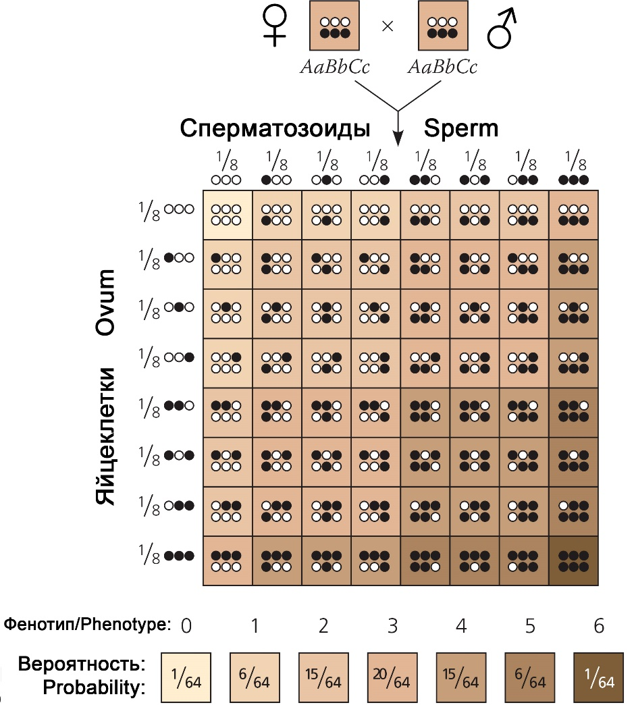

Calculate which phenotypes (from 0 to 6 units of darkness) and the probability of their occurrence for the marriage of parents with genotypes ♀AABbCc and ♂aaBBCc. In the answers, numbers indicate phenotypes, the probabilities of their occurrence are given in brackets.

Variant 1:
- 0 (1/8), 1 (3/8), 2 (3/8), 3 (1/8);
- 1 (1/8), 2 (3/8), 3 (3/8), 4 (1/8);
- 2 (1/8), 3 (3/8), 4 (3/8), 5 (1/8);
- 0 (1/8), 1 (1/8), 2 (2/8), 4 (2/8), 5 (1/8), 6 (1/8);

Variant 2:
- 1 (1/8), 2 (3/8), 3 (3/8), 4 (1/8);
- 2 (1/8), 3 (3/8), 4 (3/8), 5 (1/8);
- 3 (1/8), 4 (3/8), 5 (3/8), 6 (1/8);
- 0 (2/8), 1 (1/8), 2 (1/8), 4 (1/8), 5 (1/8), 6 (2/8);

Variant 3:
- 0 (1/8), 1 (3/8), 2 (3/8), 3 (1/8);
- 2 (1/8), 3 (3/8), 4 (3/8), 5 (1/8);
- 3 (1/8), 4 (3/8), 5 (3/8), 6 (1/8);
- 0 (1/8), 1 (2/8), 2 (1/8), 4 (1/8), 5 (2/8), 6 (1/8);

Task 18 (ID 24) – 2 points
Common part of the question for all variants:
Flower - the organ of sexual reproduction of Angiosperms is a set of modified leaves. In the flower rudiment, four circles of rudimentary leaves are formed (see the flower scheme – view from above). They then differentiate into sepals, petals, stamens, and pistil. To start the program of differentiation of these leaves during the formation of a flower rudiment, the expression of three different genes A, B and C is necessary. Proteins, which are expressed from these genes, interact in pairs to each other and direct development of a rudimentary leaves along the desired path: if only gene A is expressed, then sepals are formed; if genes A and B are expressed, then petals are formed; if genes B and C are expressed, then stamens are formed; if only the C gene is expressed, a pistil is formed.
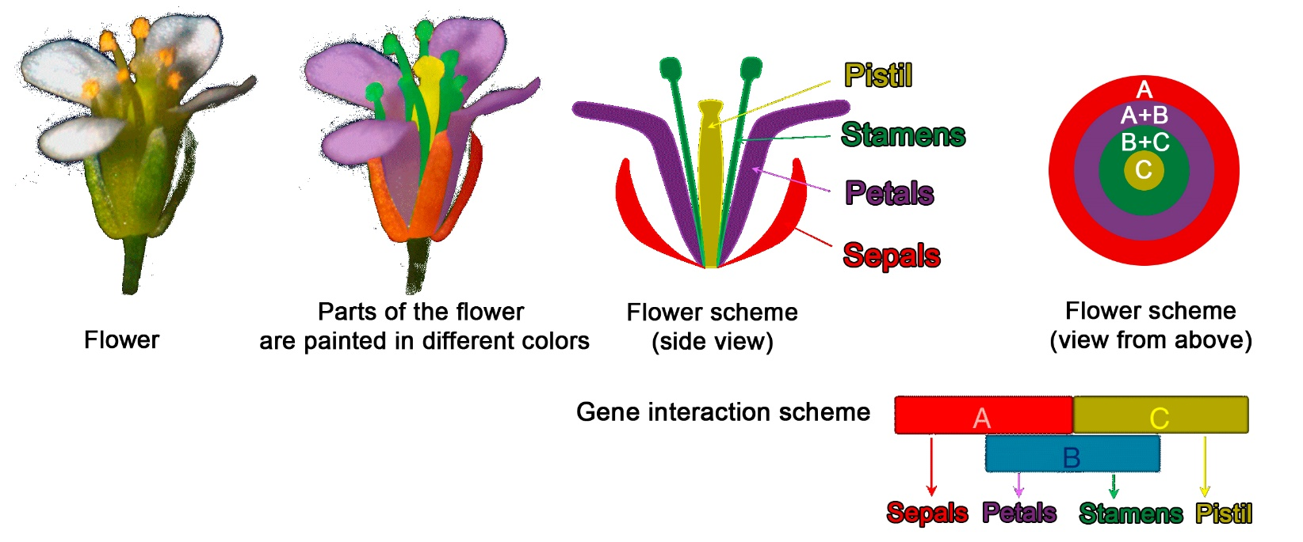
Scientists have obtained mutant plants in which different of these three genes have been deleted. As a result, the plants had flowers with various defects. Compare the given schemes of flowers of mutant plants with the name of the gene, whose deletion caused this phenotype:
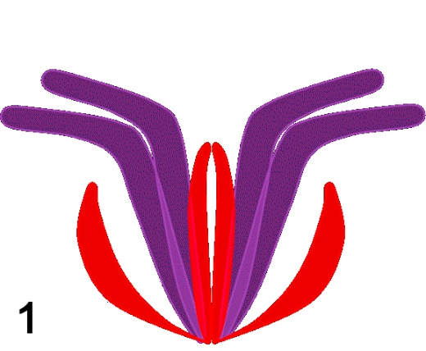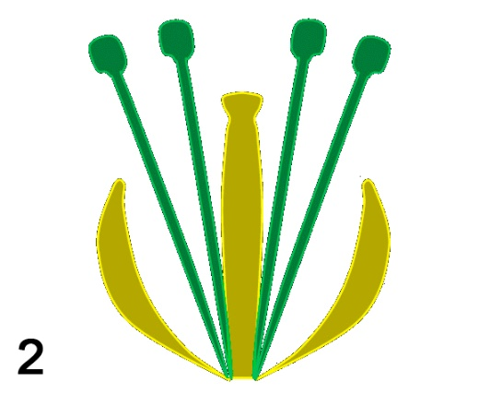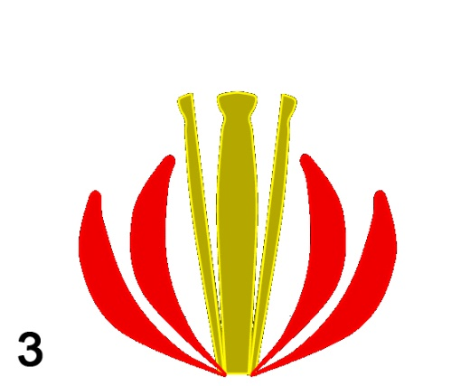

Variant 1:
- 1 – A, 2 – B, 3 – C;
- 1 – B, 2 – A, 3 – C;
- 1 – B and C, 2 – A, 3 – C;
- 1 – C, 2 – A, 3 – B;

Variant 2:
- 1 – A, 2 – C, 3 – B;
- 1 – C, 2 – A, 3 – B;
- 1 – B, 2 – C, 3 – A;
- 1 – B, 2 – A, 3 – C and B;

Variant 3:
- 1 – C, 2 – A, 3 – B;
- 1 – C, 2 – B, 3 – A;
- 1 – B, 2 – A, 3 – C;
- 1 – B, 2 – A, 3 – C and B;

Task 19 (ID 25) – 1 point
Common part of the question for all variants:
Ernst Mayr defined biological species as “groups of actually or potentially interbreeding natural populations that are isolated from other such groups by one or more mechanisms of reproductive isolation”. For which of the following organism couplets is the observation provided sufficient to call them distinct biological species?
1) Two populations are fixed for competing alleles in the wild. But heterozygous individuals can be produced in laboratory setting;
2) No mating can be found between Dalmatian and Chihuahua dogs as their body sizes differ dramatically;
3) Females of two firefly species each only respond to the light signal issued by their conspecific males;
4) A male and a female moth sample caged in a box failed to mate and lay eggs;
5) Two individuals of stag beetles with prominent difference in mandible morphology employ the same of sex pheromones.

Variant 1:
- 1 and 2;
- 1 and 3;
- only 1;
- only 3;

Variant 2:
- 2 and 3;
- 4 and 5;
- only 3;
- only 5;

Variant 3:
- only 3;
- 1 and 2;
- 3 and 4;
- 4 and 5;

Task A20 (ID 26) – 2 points
Common part of the question for all variants:
The characteristics of eight taxonomic groups indicated with A up to H are shown in the following table.

Group | Amniotic  egg | Chorda | Hair | Legs | Bony  skeleton | Teeth/  Jaws
A | - | + | - | - | - | -
B | + | + | + | + | + | +
C | - | + | - | - | + | +
D | - | + | - | + | + | +
E | + | + | - | + | + | +
F | + | + | + | + | + | +
G | - | + | - | - | - | +
H | - | - | - | - | - | -

References: “+” – feature present, “-“ – feature absent
Based upon these features complete the following evolutionary tree by writing the correct
taxon group letters in the corresponding branches. Choose the correct combination of cell numbers and taxon group letters.
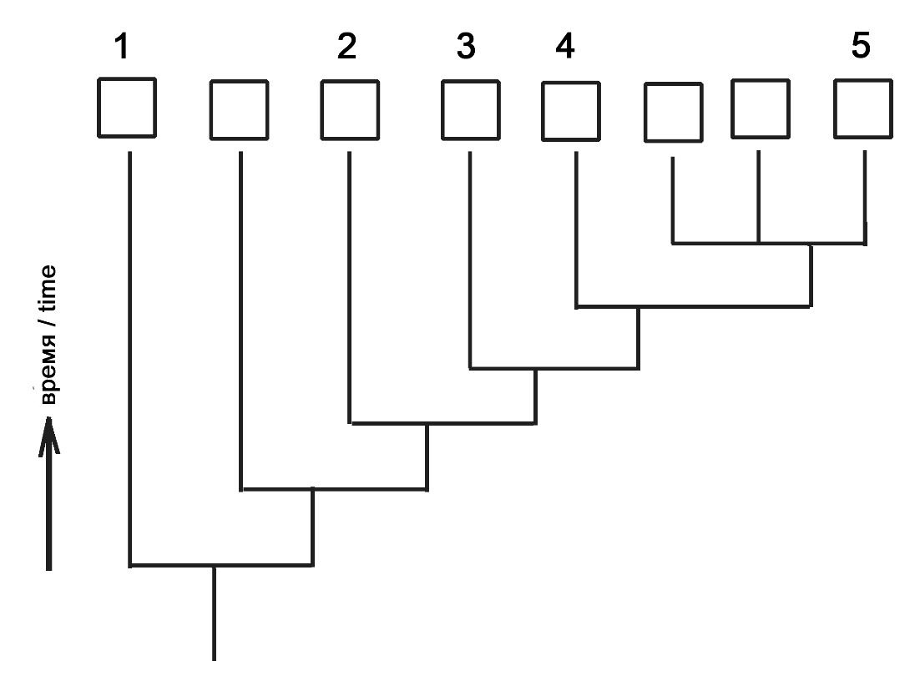

Variant 1:
- 1 – B, 2 – D, 3 – C, 4 – G, 5 – H;
- 1 – H, 2 – G, 3 – C, 4 – D, 5 – E;
- 1 – H, 2 – G, 3 – D, 4 – C, 5 – E;
- 1 – H, 2 – G, 3 – C, 4 – D, 5 – F;

Variant 2:
- 1 – F, 2 – D, 3 – C, 4 – G, 5 – H;
- 1 – H, 2 – A, 3 – D, 4 – C, 5 – E;
- 1 – H, 2 – G, 3 – C, 4 – D, 5 – B;
- 1 – H, 2 – G, 3 – C, 4 – D, 5 – E;

Variant 3:
- 1 – H, 2 – G, 3 – C, 4 – D, 5 – E;
- 1 – F, 2 – D, 3 – C, 4 – G, 5 – H;
- 1 – H, 2 – A, 3 – C, 4 – D, 5 – E;
- 1 – H, 2 – G, 3 – C, 4 – D, 5 – F;

Part B: Multiple Choice Questions (True / False)

In all the tasks of this part, there is a condition at the beginning, and then six answer options (under the letters from A to F). Participants need to determine whether each of the answer options is correct (fits the problem statement) or incorrect (does not fit the job statement). Each task can have from 0 to 6 correct answers.

Grading system:
For each correctly marked statement, you can get 0.5 points
For each incorrectly marked statement - 0 points

Task 21 (ID 28) – 3 points
Common part of the question for all variants:
The picture below shows the life cycles of algae Chara braunii (left) and moss Funaria sp. (right).
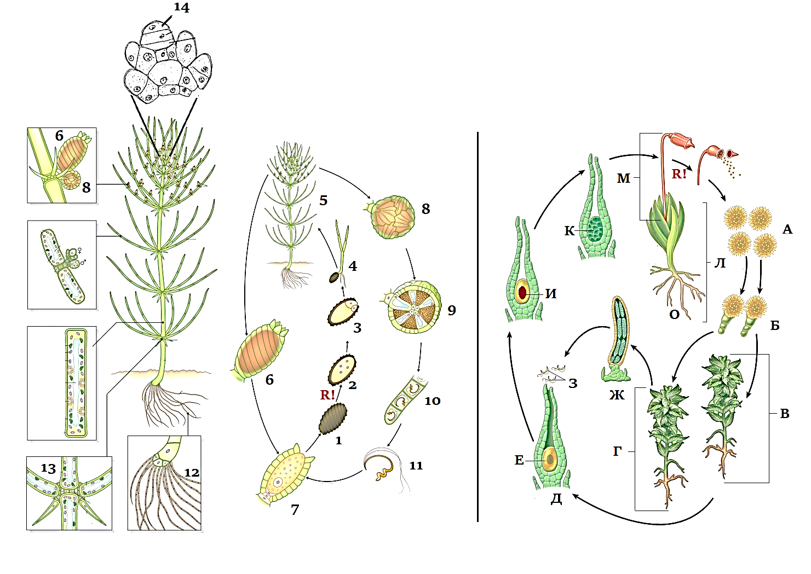
Review the picture and specify true or false for each of the following statements:

Variant 1:
- in life cycle of Chara braunii predominates haplobiont, meiosis occurs immediately after zygote formation;
- in life cycle of Chara braunii there is an alternation of generations: there are multicellular gametophyte and sporophyte, meiosis before spore formation;;
- type of sexual process in Chara braunii and Funaria sp. is oogamy: immobile large female gametes are fertilized by mobile small male gametes;
- Chara braunii is a monoecious plant because female and male gametangia are on the same organism;
- Funaria sp. is a dioecious plant because female gametangia are on one plant and male gametangia are on other;
- Funaria sp. is a monoecious plant because female and male gametangia are on the same organism;

Variant 2:
- in life cycle of Funaria sp. predominates haplobiont, meiosis occurs immediately after zygote formation;
- in life cycle of Funaria sp. there is an alternation of generations: there are multicellular gametophyte and sporophyte, meiosis before spore formation;
- the type of sexual process in Chara braunii and Funaria sp. is isogamy: there is a fusion of motile gametes of equal size and identical in morphology;
- Chara braunii is a monoecious plant because female and male gametangia are on the same organism;
- Chara braunii is a dioecious plant because female gametangia are on one plant and male gametangia are on other;
- Funaria sp. is a dioecious plant because female gametangia are on one plant and male gametangia are on other;

Variant 3:
- in life cycle of Chara braunii predominates haplobiont, meiosis occurs immediately after zygote formation;
- in life cycle of Funaria sp. there is an alternation of generations: there are multicellular gametophyte and sporophyte, meiosis before spore formation;
- type of sexual process in Chara braunii and Funaria sp. is oogamy: immobile large female gametes are fertilized by mobile small male gametes;
- Chara braunii is a monoecious plant because female and male gametangia are on the same organism;
- Funaria sp. is a dioecious plant because female gametangia are on one plant and male gametangia are on other;
- Funaria sp. is a monoecious plant because female and male gametangia are on the same organism;

Task 22 (ID 30) – 3 points
Common part of the question for all variants:
The picture below shows a diagram of life cycle of Plasmodium falciparum.
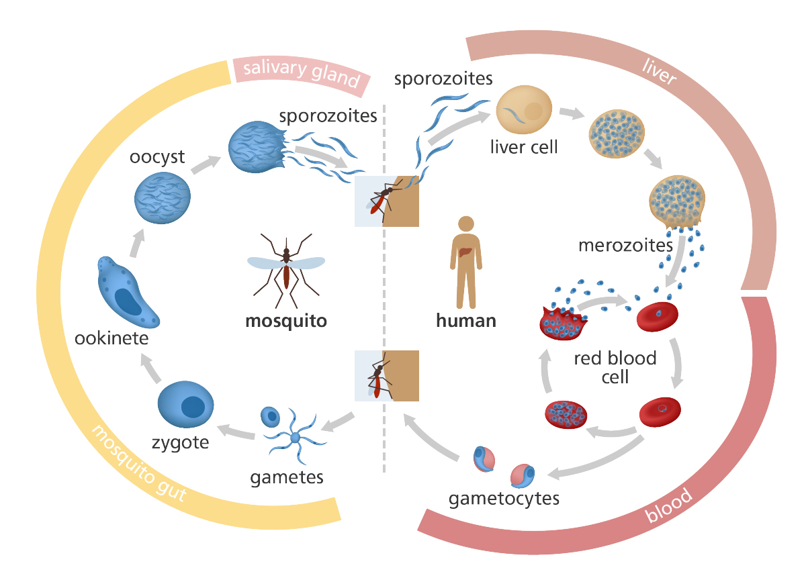
Analyze presented diagram and indicate which of the following statements are true or false:

Variant 1:
- sporozoites enter the human blood when bitten by a mosquito and are introduced into erythrocytes;
- merozoites are the sexual generation that reproduces in human erythrocytes;
- the final host of the parasite is a human, because sexual reproduction of the parasite occurs in the human blood;
- ookinete penetrates into intestinal wall of mosquito and undergoes meiotic division, therefore, all other stages of plasmodium carry a haploid set of chromosomes;
- ookinete divided by sporogony and forms many sporozoites, which penetrate into salivary glands of mosquito;
- during the life cycle, malaria plasmodium multiplies asexually twice - in human liver cells and in oocyte in mosquito intestinal wall;

Variant 2:
- sporozoites are able to penetrate into human liver cells and multiply there by schizogony;
- merozoites are able to penetrate into human erythrocytes and multiply by schizogony;
- the final host of the parasite is a malaria mosquito, because fusion of parasite's gametes occurs in the gut of mosquito;
- ookinete divided by sporogony and forms many sporozoites, which penetrate into salivary glands of mosquito;
- oocyst and sporozoites are diploid stages and meiosis occurs only at the stage of reproduction in human erythrocytes, when gametocytes are formed;
- during the life cycle, malaria plasmodium multiplies asexually three times - in human liver cells and in erythrocytes, in an oocyte in intestinal wall of a mosquito;

Variant 3:
- sporozoites enter the human blood when bitten by a mosquito and are introduced into erythrocytes;
- sporozoites are able to penetrate into human liver cells and multiply there by schizogony;
- merozoites are able to penetrate into human erythrocytes and multiply by schizogony;
- merozoites are able to form sexual forms - female and male gametocytes, which circulate in human blood;
- the final host of the parasite is a malaria mosquito, because fusion of parasite's gametes occurs in the gut of mosquito;
- oocyst and sporozoites are diploid stages and meiosis occurs only at the stage of reproduction in human erythrocytes, when gametocytes are formed;

Task 23 (ID 32) – 3 points
Common part of the question for all variants:
The figure below shows some of the internal organs of human.
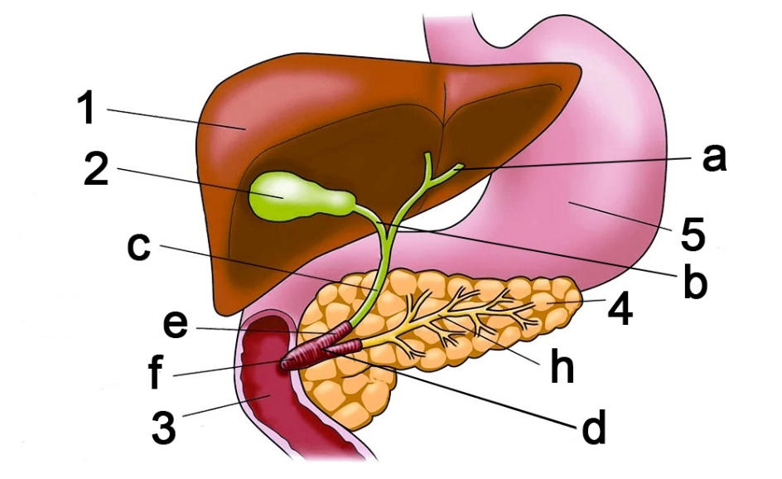
Based on this picture, indicate which of the following statements are true or false:

Variant 1:
- hormone cholecystokinin acts only on organs 2 and 4;
- organ designated as 1 is capable of synthesizing the following proteins: serum albumin, angiotensin, fibrinogen;
- structure marked by letter "a" in the figure is called the ureter;
- structure marked by letter "h" in the figure is called the pancreatic duct;
- organ designated as 4 is capable for synthesizing the following enzymes: lactase, pepsin;
- organ designated as 4 synthesizes insulin, which increases the absorption of glucose by adipose tissue and muscles, and also reduces ketogenesis in the organ designated as 1;

Variant 2:
- hormone cholecystokinin acts only on organs 3 and 5;
- organ designated as 1 is able to synthesize the following proteins: renin, growth hormone, vasopressin, glucagon;
- structure marked by letter "c" in the figure is called the common bile duct;
- organ designated as 4 is capable for synthesizing the following enzymes: nucleases, lipases, trypsinogen, chymotrypsinogen;
- organ designated as 4 is capable for synthesizing the following enzymes: lactase, pepsin;
- organ designated as 4 synthesizes insulin, which reduces the absorption of glucose by adipose tissue and muscles, and also reduces the synthesis of lipids in the organ designated as 1;

Variant 3:
- hormone cholecystokinin acts only on organs 2 and 4;
- organ designated as 1 is able to synthesize the following proteins: renin, growth hormone, vasopressin, glucagon;
- structure marked by letter "c" in the figure is called the common bile duct;
- structure marked by letter "h" in the figure is called the pancreatic duct;
- organ designated as 4 is capable for synthesizing the following enzymes: nucleases, lipases, trypsinogen, chymotrypsinogen;
- organ designated as 4 synthesizes insulin, which increases the absorption of glucose by adipose tissue and muscles, and also reduces ketogenesis in the organ designated as 1;

Task 24 (ID 33) – 3 points
Common part of the question for all variants:
A group of students studied the topic "Structure of carbohydrates". At the lecture, they learned that monosaccharides can exist in solution in an open chain form (Fischer projections) and in a closed ring form (Haworth structures). In the textbook, they found instructions on how to get the ring formula from the chain formula of D-glucose.
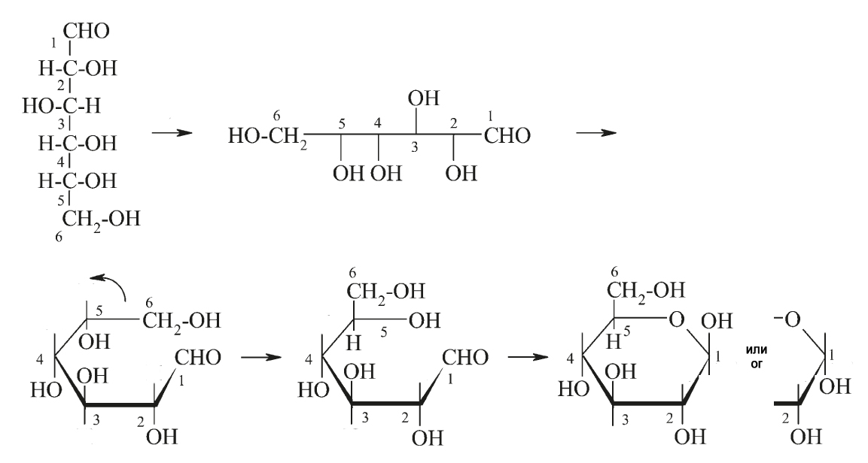
The students decided to practice converting D-mannose from chain to ring. In total, they got five different formulas:
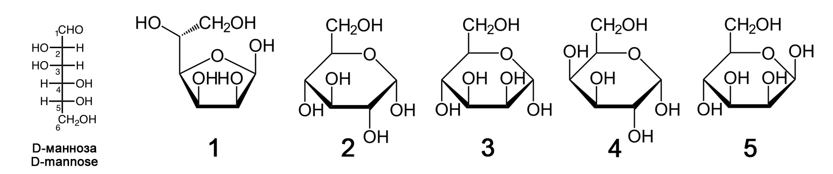
Analyze the formulas and specify true or false for each of the following statements:

Variant 1:
- all five formulas created by the students are not mannose formulas;
- formula 1 is incorrect, because only six atoms can form a ring, but not five atoms as in this formula;
- formula 2 is a glucose, the error is that the OH group on the second carbon atom is incorrectly oriented;
- formula 3 is the formula for mannose in alpha orientation of OH group at first carbon atom;
- formula 4 is the formula for mannose in furanose form (five atoms in ring) and not in pyranose form;
- formula 5 is the formula for fructose, a monosaccharide found in sucrose;

Variant 2:
- mannose is represented by formulas 2, 3 and 4, but formulas 1 and 5 are other carbohydrates;
- formula 1 represents mannose in furanose form (five atoms in ring);
- formula 2 is the mannose formula in L-form, not D-form;
- formula 3 is the formula of lyxose, a disaccharide found in blood of insects;
- formula 4 is the formula for galactose, a monosaccharide found in lactose;
- formula 5 is the formula for mannose in beta orientation of OH group at first carbon atom;

Variant 3:
- mannose is represented by formulas 1, 3 and 5, but formulas 2 and 4 are other carbohydrates;
- formula 1 represents mannose in furanose form (five atoms in ring);
- formula 2 is the mannose formula in L-form, not D-form;
- formula 3 is the formula for mannose in alpha orientation of OH group at first carbon atom;
- formula 4 is the formula for galactose, a monosaccharide found in lactose;
- formula 5 is the formula for fructose, a monosaccharide found in sucrose;

Task 25 (ID 34) – 3 points
Common part of the question for all variants:
The scheme below shows the reactions of the tricarboxylic acid cycle (Krebs cycle).
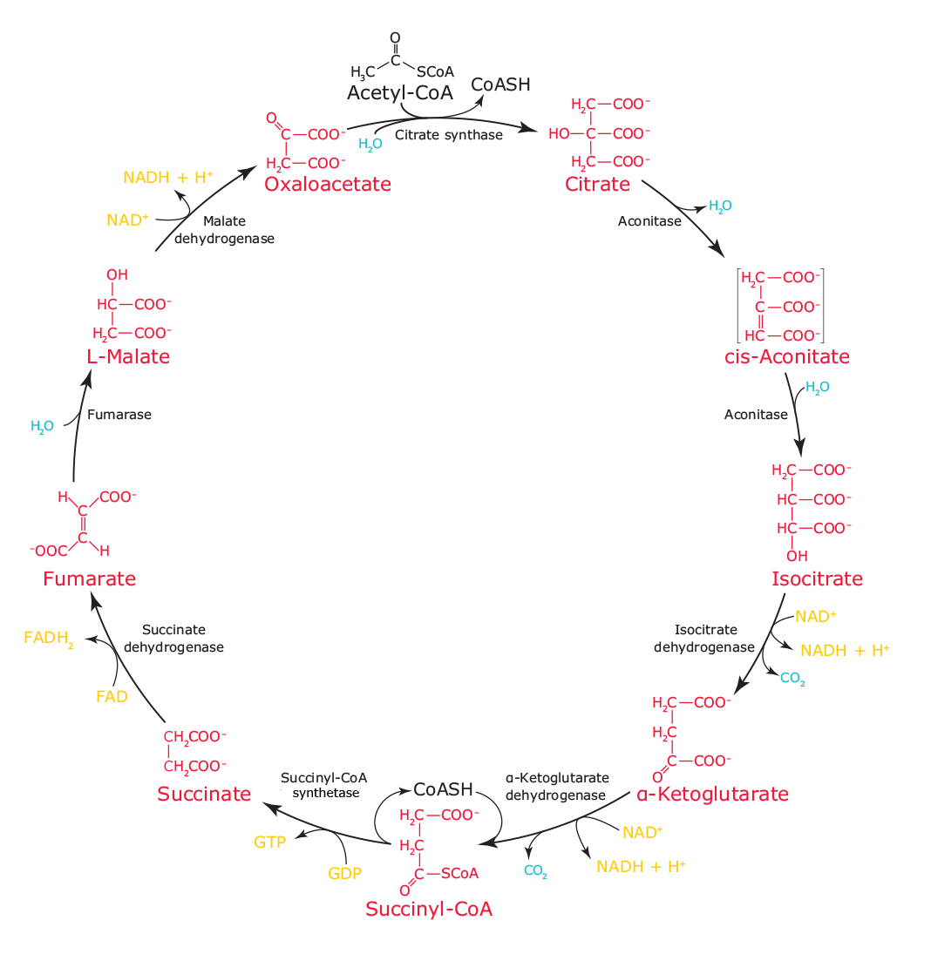
Analyze reaction scheme and specify true or false for each of the following statements:

Variant 1:
  - during the Krebs cycle formed 2 molecules of CO₂, 3 NADH, 1 FADH₂ and 1 GTP;
  - enzymes of the Krebs cycle reaction indicated in this scheme are capable work in forward and reverse directions, therefore the cycle can go clockwise and counterclockwise;
  - Krebs cycle is localized in the cytoplasm of prokaryotes, but in the mitochondria of eukaryotes;
  - oxaloacetate can be used to synthesize glutamic acid;
  - succinate dehydrogenase is tightly bound to inner mitochondrial membrane and participates in electron transport chain;
  - coenzyme A is involved in only one reaction shown on this scheme;

Variant 2:
  - enzymes of the Krebs cycle reaction indicated in this scheme are capable work in forward and reverse directions, therefore the cycle can go clockwise and counterclockwise;
  - acetyl-CoA enters in cycle from pyruvate (formed in glycolysis) or from beta-oxidation of fatty acids;
  - enzymes of Krebs cycle in prokaryotes and eukaryotes are localized in mitochondria;
  - alpha ketoglutarate can be used to synthesize glutamic acid;
  - energy yield of Krebs cycle is 10 ATP molecules in one cycle (NADH gives 2.5 ATP molecules and FADH₂ gives 1.5 ATP molecules in electron transport chain);
  - acetyl coenzyme A is involved in only one reaction shown on this scheme;

Variant 3:
  - acetyl-CoA enters in cycle from pyruvate (formed in glycolysis) or from beta-oxidation of fatty acids;
  - Krebs cycle is localized in the cytoplasm of prokaryotes, but in the mitochondria of eukaryotes;
  - alpha ketoglutarate can be used to synthesize glutamic acid;
  - energy yield of Krebs cycle is 10 ATP molecules in one cycle (NADH gives 2.5 ATP molecules and FADH₂ gives 1.5 ATP molecules in electron transport chain);
  - succinate dehydrogenase is tightly bound to inner mitochondrial membrane and participates in electron transport chain;
  - hydration reaction of fumarate to malate is irreversible;

Task 26 (ID 35) – 3 points
Common part of the question for all variants:
Schematic representation of Escherichia coli replicative fork shown on picture below.
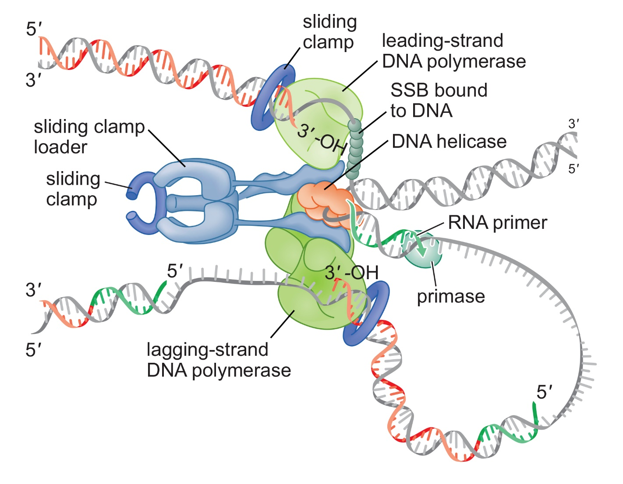
Analyze presented scheme and determine which of the statements are true or false:

Variant 1:
- replication occurs simultaneously on two strands of parent DNA molecule: replication proceeds continuously on leading strand, but on lagging strand, DNA is synthesized piece by piece (Okazaki fragments);
- DNA helicase is required to separate chains of parent DNA molecule;
- RNA primer is synthesized by DNA polymerase on a lagging strand;
- sliding clamp is a special complex of proteins that increases the efficiency of DNA polymerase by fixing it on the template DNA strand;
- SSB proteins are required so that DNA polymerase on leading strand does not inhibit DNA helicase;
- complex of sliding clamp loader and special tau-proteins provides association of DNA polymerases on lagging and leading strands into a strong complex;

Variant 2:
- DNA helicase is necessary for DNA synthesis on a lagging strand;
- primase is an RNA polymerase that synthesizes short RNA primers, which are necessary to start synthesis of daughter DNA strand by DNA polymerase;
- sliding clamp is necessary to stop DNA polymerase during synthesis on a lagging strand when it reaches the previous Okazaki fragment;
- DNA polymerase synthesizes DNA by transferring NTF to 3'-OH group of growing DNA strand;
- SSB proteins bind to single-stranded DNA and prevent formation of a DNA duplex;
- termination of DNA synthesis in replication fork occurs when DNA helicase interacts with primase;

Variant 3:
- DNA helicase is required to separate chains of parent DNA molecule;
- RNA primer is synthesized by DNA polymerase on a lagging strand;
- sliding clamp loader complex is required to install sliding clamp on template DNA strand close to RNA primer;
- DNA polymerase synthesizes DNA by transferring NTF to 3'-OH group of growing DNA strand;
- SSB proteins are required so that DNA polymerase on leading strand does not inhibit DNA helicase;
- termination of DNA synthesis in replication fork occurs when DNA helicase interacts with primase;

Task 27 (ID 36) – 3 points
Common part of the question for all variants:
On August 11, 2020, the first vaccine against SARS-CoV-2 virus was registered in Russia. This vaccine based on technology using human adenoviruses. They deliver S-protein into human cells. S-protein is a surface protein of coronavirus responsible for binding to a receptor (angiotensin converting enzyme 2) on surface of human cells. An approximate diagram describing process of formation of immunity in response to this vaccine is shown below.
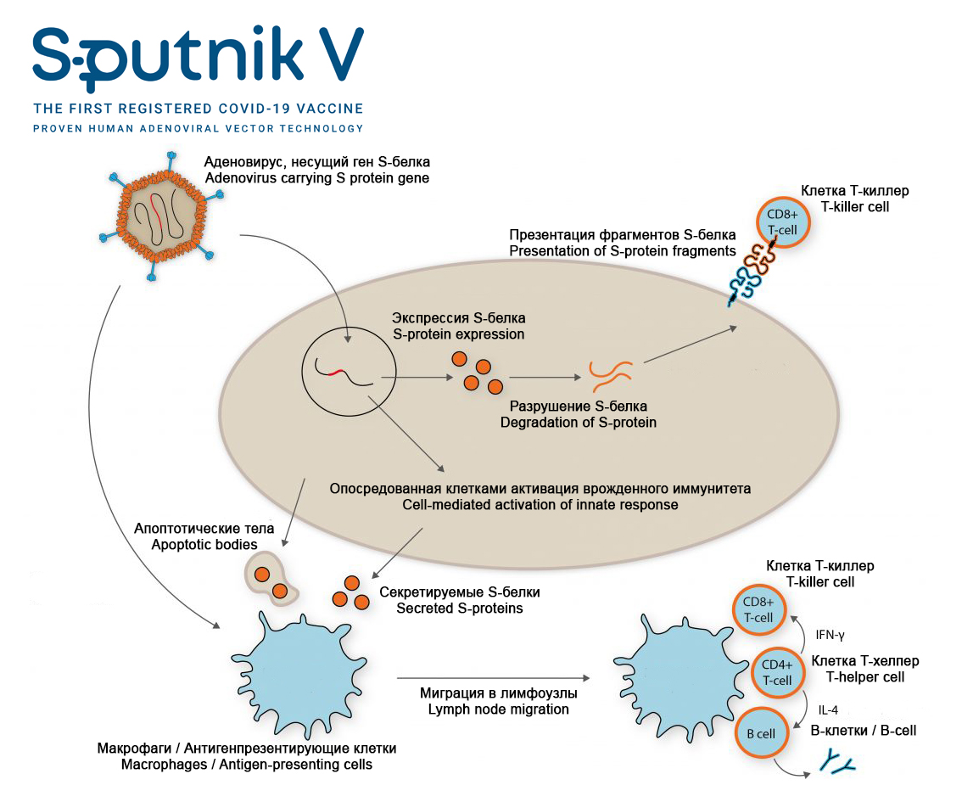

Analyze presented scheme and determine which of the statements are true or false:

Variant 1:
- this vaccine does not use SARS-CoV-2 virus, so there is no risk of COVID-19 infection for patients;
- modified adenoviruses are used in this vaccine to transfer (deliver) a gene encoding surface S-protein of SARS-CoV-2 virus into human cells;
- surface S-protein of SARS-CoV-2 virus is expressed after entry of adenovirus into human cell;
- the cell can present S-protein to T-killers (CD8⁺ T-cell), which causes activation of cellular antiviral systems and/or apoptosis;
- S-protein secreted by cells and apoptotic bodies can enter macrophages and antigen-presenting cells;
- macrophages and antigen-presenting cells activate T-helpers (CD4⁺ T-cell), which further activate T-killers (CD8⁺ T-cell) and B-lymphocytes, which leads to formation of cellular and humoral immunity;

Variant 2:
- this vaccine uses an inactivated (killed) SARS-CoV-2 virus, therefore, COVID-19 infection is possible if virus is not completely inactivated during manufacture of vaccine;
- modified adenoviruses are used in this vaccine to transfer (deliver) a gene encoding surface S-protein of SARS-CoV-2 virus into human cells;
- modified adenoviruses cause COVID-19 in humans;
- macrophages and antigen-presenting cells activate T-helpers (CD4⁺ T-cell), which further activate T-killers (CD8⁺ T-cell) and B-lymphocytes, which leads to formation of cellular and humoral immunity;
- B-lymphocytes are needed to develop cellular immunity and destroy all cells infected with adenovirus and coronavirus (with subsequent infection);
- main advantage of this vaccine is that it leads to formation of humoral (antibodies) and cellular (T-cells) immunity to S-protein of SARS-CoV-2 virus;

Variant 3:
- this vaccine does not use SARS-CoV-2 virus, so there is no risk of COVID-19 infection for patients;
- modified adenoviruses are harmless to humans;
- the cell can present S-protein to T-killers (CD8⁺ T-cell), which causes activation of cellular antiviral systems and/or apoptosis;
- macrophages and antigen-presenting cells activate T-helpers (CD4⁺ T-cell), which further activate T-killers (CD8⁺ T-cell) and B-lymphocytes, which leads to formation of cellular and humoral immunity;
- certain B-lymphocytes are capable of producing antibodies that bind to S-protein of SARS-CoV-2 virus;
- this vaccine only leads to production of antibodies to S-protein of SARS-CoV-2 virus, but does not lead to formation of memory T-cells and T-killers (CD8 + T-cell), which can kill cells infected by SARS-CoV-2;

Task 28 (ID 37) – 3 points
Common part of the question for all variants:
In maize a single locus determines the color of the seed; allele «A» results in colored seeds, and allele «a» in colorless seeds. Another locus determines the shape of the seeds; allele «B» results in a smooth shape of the seeds, and «b» in wrinkled seeds.
In a crossbreeding between the plant that grew from a colored and smooth seed and the plant that grew from a colorless and wrinkled seed, the offspring were documented as:
376 had colored and smooth seeds;
13 had colored and wrinkled seeds;
13 had colorless and smooth seeds;
373 had colorless and wrinkled seeds;
This experiment 1 made it possible to establish the genotypes of the parent plants and the frequency of occurrence of recombinants.
In addition, maize has three other loci: «C», «D» and «E», which are located on the same chromosome in this order. Using similar experiments 2 to the above, we found that the frequency of recombinants between «C» and «D» is 10% and that between «D» and «E» it is 20%.
For each of the following statements regarding the results of two described experiments, indicate whether it is true or false:

Variant 1:
- genotypes of the parent plants in experiment 1 were: AABb x aaBb;
- genotypes of the parent plants in experiment 1 were: AaBb x aabb;
- frequency of recombinants in experiment 1 is: 0.335%;
- frequency of recombinants in experiment 1 is: 1.68%;
- assuming that crossing over occurs randomly on the chromosome, expected frequency of recombination between «C» and «E» in experiment 2 is: 26%;
- assuming that crossing over occurs randomly on the chromosome, expected frequency of recombination between «C» and «E» in experiment 2 is: 30%;

Variant 2:
- genotypes of the parent plants in experiment 1 were: AaBb x aabb;
- genotypes of the parent plants in experiment 1 were: AAbb x aaBB;
- frequency of recombinants in experiment 1 is: 3.35%;
- frequency of recombinants in experiment 1 is: 6.91%;
- assuming that crossing over occurs randomly on the chromosome, expected frequency of recombination between «C» and «E» in experiment 2 is: 26%;
- assuming that crossing over occurs randomly in the chromosome, expected frequency of recombination between «C» and «E» in experiment 2 is: 34%;

Variant 3:
- genotypes of the parent plants in experiment 1 were: AaBb x aabb;
- genotypes of the parent plants in experiment 1 were: aabb x AABB;
- frequency of recombinants in experiment 1 is: 0.335%;
- frequency of recombinants in experiment 1 is: 3.35%;
- assuming that crossing over occurs randomly on the chromosome, expected frequency of recombination between «C» and «E» in experiment 2 is: 30%;
- assuming that crossing over occurs randomly on the chromosome, expected frequency of recombination between «C» and «E» in experiment 2 is: 2%;

Task 29 (ID 38) – 3 points
Common part of the question for all variants:
In one of species of butterflies, wing color is determined by a locus containing three alleles: R-all (entirely red wings), R-fourth (white spot on a quarter of wing surface), R-half (white spot on half of wing surface). Allele dominance is distributed as: R-all> R-fourth> R-half. When studying a large population of butterflies living on outskirts of Dolgoprudny, following allele frequencies were found: R-all = 0.5, R-fourth = 0.4, and R-half = 0.1.

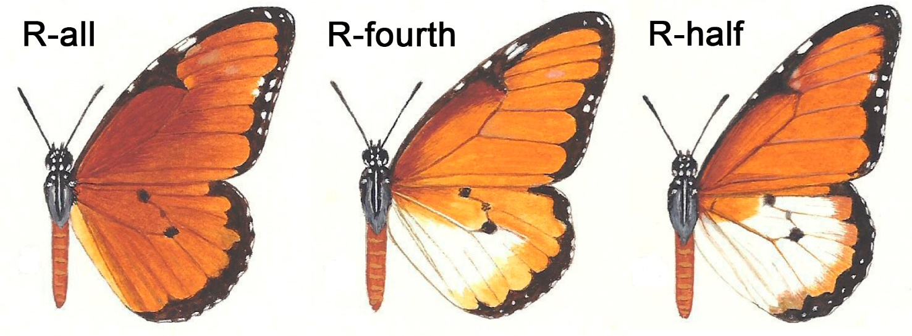

As a result, of construction of the third runway at Sheremetyevo airport, a small group of butterflies was isolated from the main population and gave rise to a new population. After several generations, following phenotype frequencies were observed in this new population: R-all = 0, R-fourth = 0.75, and R-half = 0.25.
Remember Hardy–Weinberg principle and for above statements, indicate whether it is true or false:

Variant 1:
- if butterflies in main population continue to interbreed randomly, then in next generation frequency of individuals with R-all phenotypes will be 0.75, R-fourth – 0.24 and R-half – 0.01;
- if butterflies in main population continue to interbreed randomly, then in next generation frequency of individuals with R-all phenotypes will be 0.83, R-fourth – 0.16 and R-half – 0.01;
- if main population includes 6500 butterflies, then number of butterflies of R-all phenotype will be 4875, R-fourth – 1560 and R-half – 65;
- if main population includes 6500 butterflies, then number of butterflies of R-all phenotype will be 5395, R-fourth – 1040 and R-half – 65;
- in new butterfly population, allele frequencies are: R-all = 0, R-fourth = 0.5 and R-half = 0.5;
- compared to the original population, change in allele frequency in the new population is an example of a natural selection;

Variant 2:
- if butterflies in main population continue to interbreed randomly, then in next generation frequency of individuals with R-all phenotypes will be 0.75, R-fourth – 0.24 and R-half – 0.01;
- if butterflies in main population continue to interbreed randomly, then in next generation frequency of individuals with R-all phenotypes will be 0.24, R-fourth – 0.75 and R-half – 0.01;
- if main population includes 6500 butterflies, then number of butterflies of R-all phenotype will be 5395, R-fourth – 1040 and R-half – 65;
- if main population includes 6500 butterflies, then number of butterflies of R-all phenotype will be 1560, R-fourth – 4875 and R-half – 65;
- in new butterfly population, allele frequencies are: R-all = 0, R-fourth = 0.75 and R-half = 0.25;
- compared to the original population, change in allele frequency in the new population is an example of a founder principle;

Variant 3:
- if butterflies in main population continue to interbreed randomly, then in next generation frequency of individuals with R-all phenotypes will be 0.83, R-fourth – 0.16 and R-half – 0.01;
- if butterflies in main population continue to interbreed randomly, then in next generation frequency of individuals with R-all phenotypes will be 0.24, R-fourth – 0.75 and R-half – 0.01;
- if main population includes 6500 butterflies, then number of butterflies of R-all phenotype will be 4875, R-fourth – 1560 and R-half – 65;
- if main population includes 6500 butterflies, then number of butterflies of R-all phenotype will be 1560, R-fourth – 4875 and R-half – 65;
- in new butterfly population, allele frequencies are: R-all = 0.25, R-fourth = 0.5 and R-half = 0.25;
- compared to the original population, change in allele frequency in the new population is an example of a bottleneck effect;

Task 30 (ID 39) – 3 points
Common part of the question for all variants:
In an old evolutionary textbook, you found a figure of an evolutionary tree.
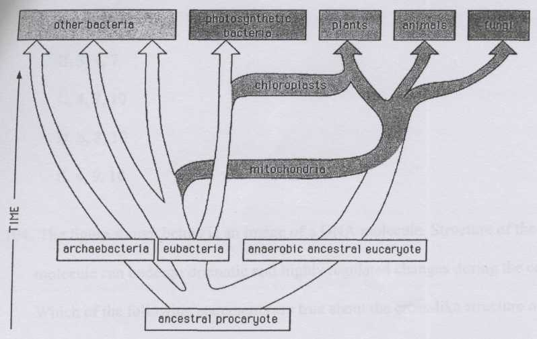
Which of the following statements about evolution are true and deducible from the figure?

Variant 1:
- All eucaryotic cells contain mitochondria;
- Symbiosis of the eucaryotic ancestor with autotrophic cells preceded the symbiosis with the cell taking advantage of the oxidative metabolism;
- The ancestral eukaryote was anaerobic;
- Mitochondria and chloroplasts have similar genomes;
- Fungi lost chloroplasts during evolution;
- Bacteria are a highly homogenous group of organisms, which showed rapid diversification of their genomes and metabolisms during the last billion years;

Variant 2:
- All eucaryotic cells contain mitochondria;
- There is a common ancestor of eubacteria and eukaryota, archaebacteria are a group with unique and independent origin;
- The ancestral eukaryote was anaerobic;
- None of the recent photosynthetic bacteria are related to the chloroplasts;
- Mitochondria are present in the cells of the plants, animals and fungi;
- Chloroplasts and mitochondria are results of independent endosymbiotic events;

Variant 3:
- Symbiosis of the eucaryotic ancestor with autotrophic cells preceded the symbiosis with the cell taking advantage of the oxidative metabolism;
- There is a common ancestor of eubacteria and eukaryota, archaebacteria are a group with unique and independent origin;
- None of the recent photosynthetic bacteria are related to the chloroplasts;
- Mitochondria and chloroplasts have similar genomes;
- Bacteria are a highly homogenous group of organisms, which showed rapid diversification of their genomes and metabolisms during the last billion years;
- Chloroplasts and mitochondria are results of independent endosymbiotic events;

Part C: Matching Questions

In the tasks of this part, the participants need to analyze various photographs, drawings, diagrams (marked with Arabic numerals) and compare them with elements from the two lists below (marked with Latin letters and Roman numerals). As an answer in each task, the participants must draw arrows between the elements being compared.

Grading system:
For each correctly indicated match between elements of 1 and 2 rows or 1 and 3 rows, the participant receives 0.5 points.
For each incorrect match - 0 points.
Task 31 (ID 40) – 5 points
Variant 1
Nikolai Vavilov is a russian geneticist, botanist and agronomist. He organized and headed several botanical and agronomic expeditions, covering most of the continents, in which he discovered ancient centers of origin of cultivated plants. Based on these materials, he created hypothesis about the world centers of origin of cultivated plants. He identified seven such centers (see map and list below).
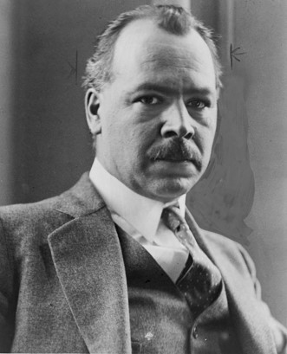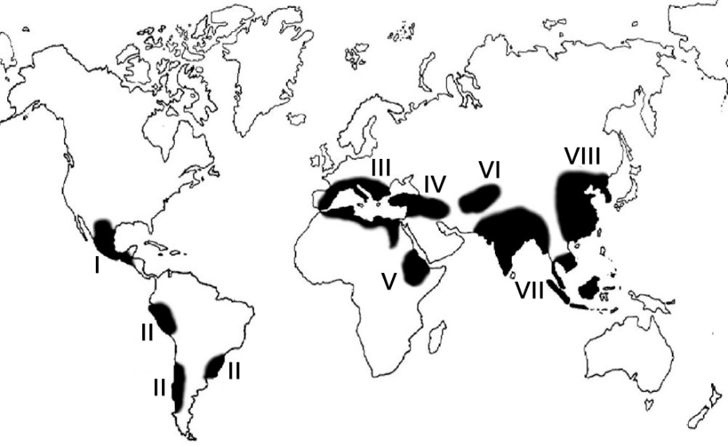
The task contains five photographs of cultivated plants, you need to correctly compare these plants with the proposed names and centers of origin (according to N. Vavilov):

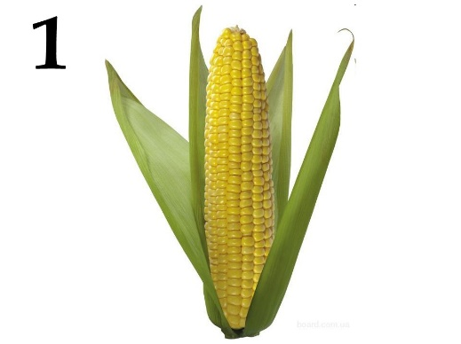 | 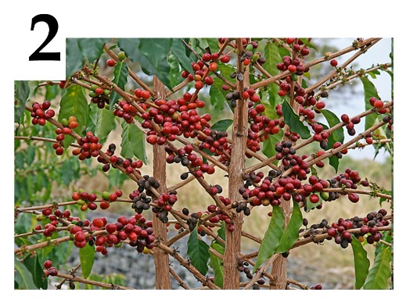 | 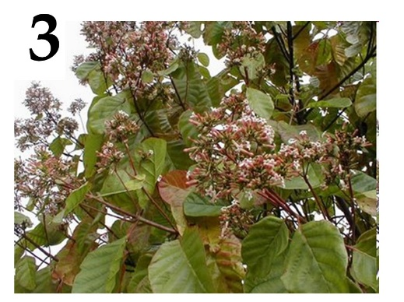
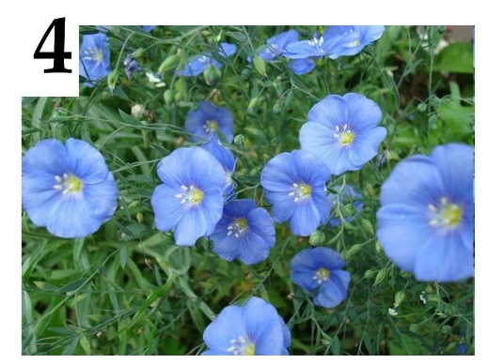 | 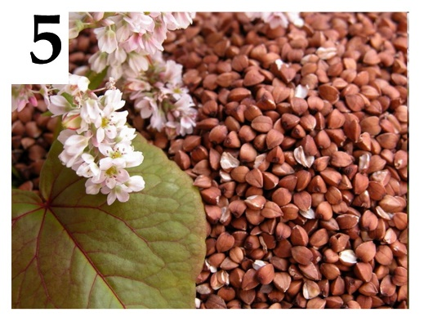

List of plant names (this list is redundant - it contains unnecessary names):
- Pineapple (Ananas comosus);
- Cinchona (Cinchona sp.);
- Coffee tree (Coffea sp.);
- Buckwheat (Fagopyrum sp.);
- Flax (Linum sp.);
- Olive tree (Olea europaea);
- Sugarcane (Saccharum officinarum);
- Rye (Secale cereale);
- Cocoa (Theobroma cacao);
- Corn (Zea mays);

List of centers of origin of cultivated plants (this list is redundant):
- Central American (Mexico, Central America);
- South American (Peru, Ecuador, Bolivia);
- Mediterranean;
- West Asian (Lebanon, Israel, Syria, Iraq);
- Abyssinian (Sudan, Eritrea);
- Central Asian (Pakistan, Afghanistan, Turkmenistan);
- Indian and Indo-Malay;
- East Asia Center (Chinese);

Task 31 (ID 40) – 5 points
Variant 2
Nikolai Vavilov is a russian geneticist, botanist and agronomist. He organized and headed several botanical and agronomic expeditions, covering most of the continents, in which he discovered ancient centers of origin of cultivated plants. Based on these materials, he created hypothesis about the world centers of origin of cultivated plants. He identified seven such centers (see map and list below).
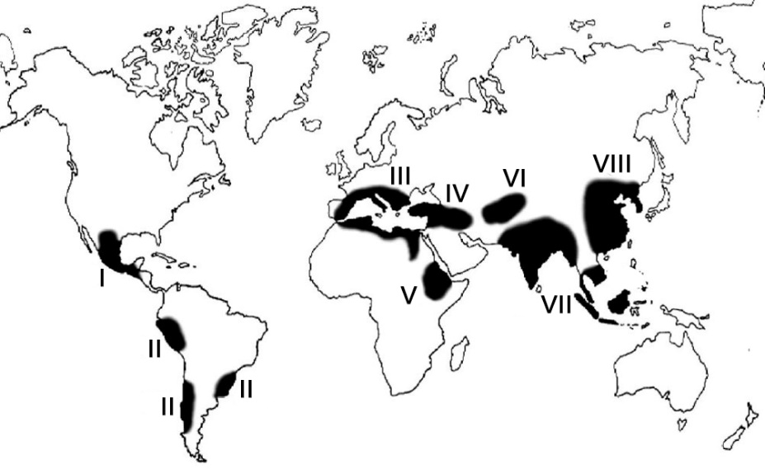
The task contains five photographs of cultivated plants, you need to correctly compare these plants with the proposed names and centers of origin (according to N. Vavilov):

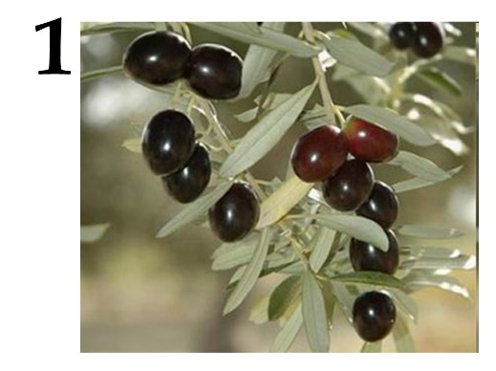 | 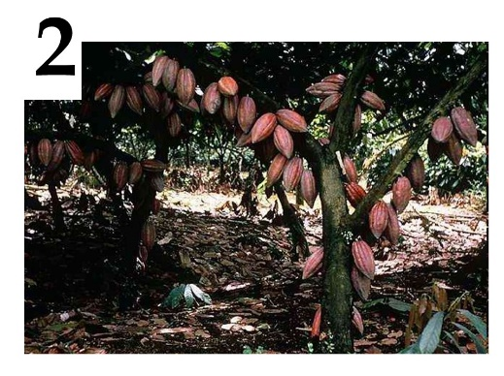 | 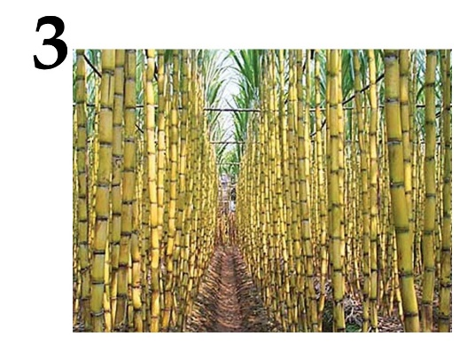
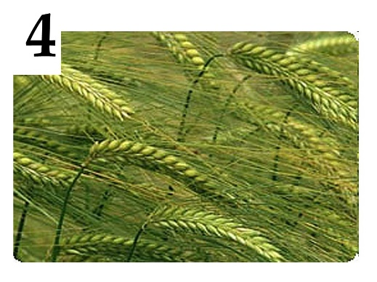 | 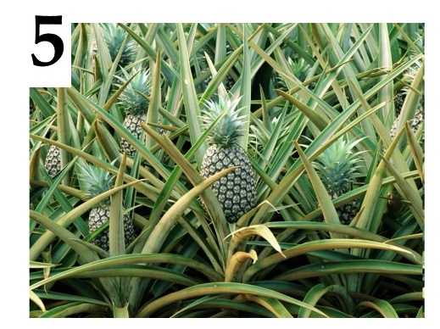

List of plant names (this list is redundant - it contains unnecessary names):
- Pineapple (Ananas comosus);
- Cinchona (Cinchona sp.);
- Coffee tree (Coffea sp.);
- Buckwheat (Fagopyrum sp.);
- Flax (Linum sp.);
- Olive tree (Olea europaea);
- Sugarcane (Saccharum officinarum);
- Rye (Secale cereale);
- Cocoa (Theobroma cacao);
- Corn (Zea mays);

List of centers of origin of cultivated plants (this list is redundant):
- Central American (Mexico, Central America);
- South American (Peru, Ecuador, Bolivia);
- Mediterranean;
- West Asian (Lebanon, Israel, Syria, Iraq);
- Abyssinian (Sudan, Eritrea);
- Central Asian (Pakistan, Afghanistan, Turkmenistan);
- Indian and Indo-Malay;
- East Asia Center (Chinese);

Task 32 (ID 41) – 5 points
Variant 1
You need to compare the juvenile and imaginal forms of various animals and choose a special term that denotes the juvenile form of animal shown on photo.

Juvenile forms:
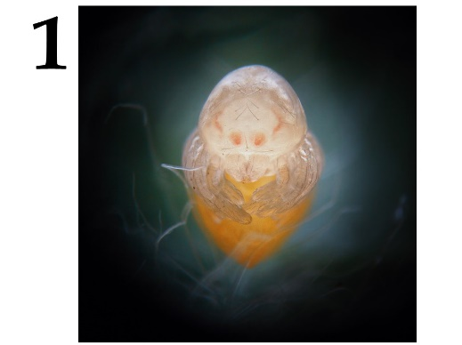 | 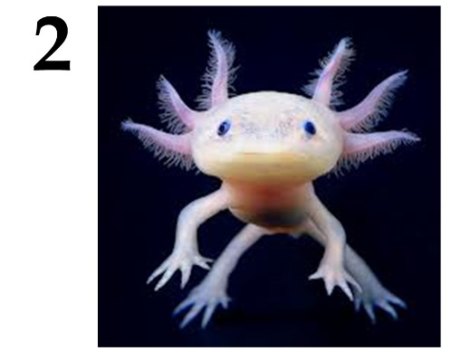 | 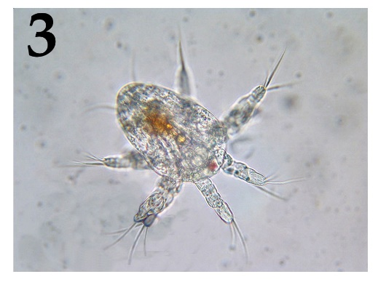
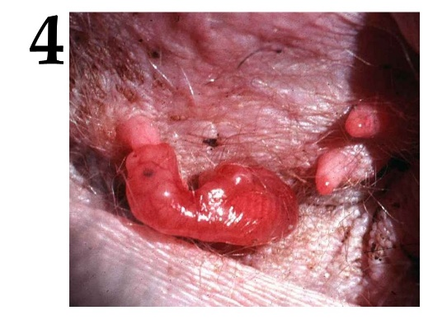 | 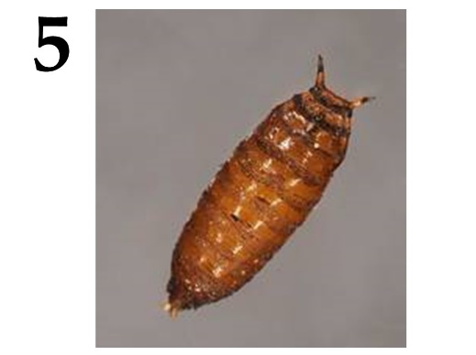

Imaginal forms:
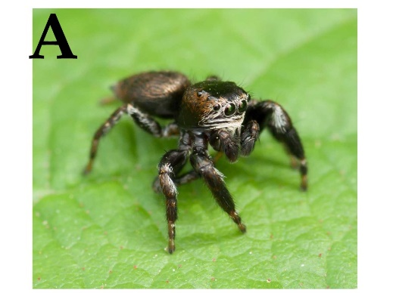 | 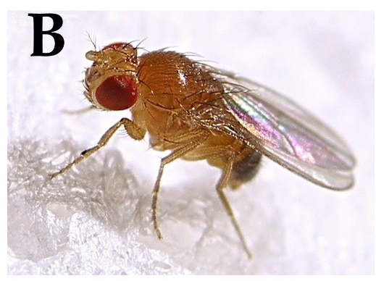 | 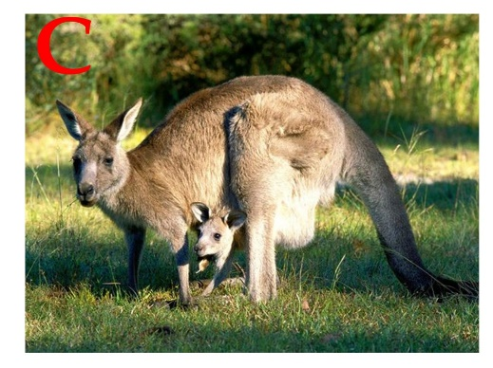
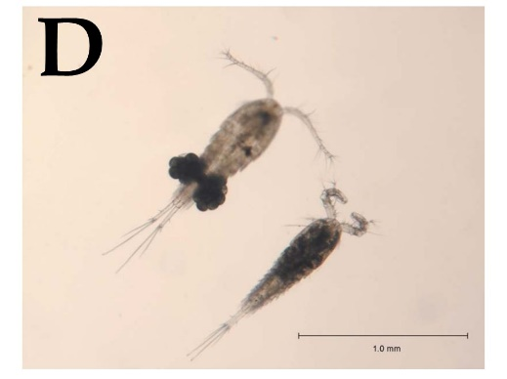 | 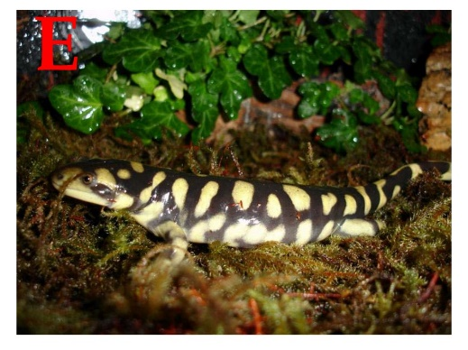

List of juvenile form names (the list is redundant - there are extra names):
- Axolotl;
- Cub;
- Chrysalis;
- Miracidium;
- Nauplius;
- Nymph;
- Sandworm;
- Polyp, strobe;

Task 32 (ID 41) – 5 points
Variant 2
You need to compare the juvenile and imaginal forms of various animals and choose a special term that denotes the juvenile form of animal shown on photo.

Juvenile forms:
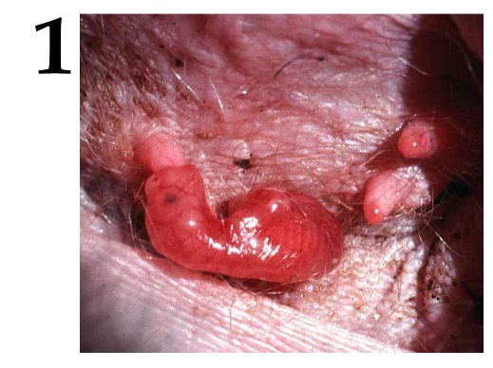 | 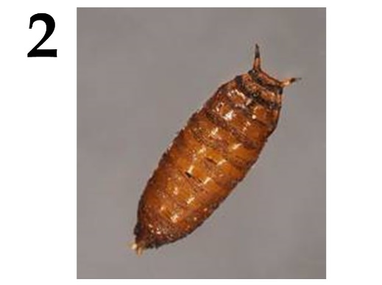 | 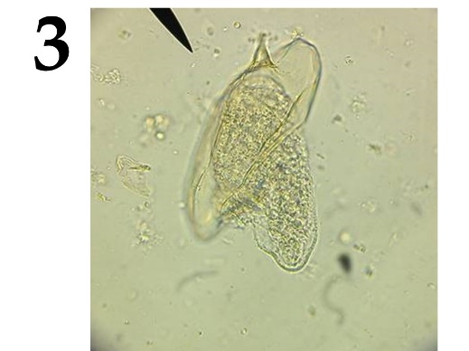
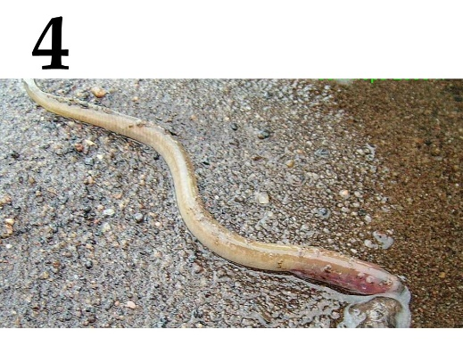 | 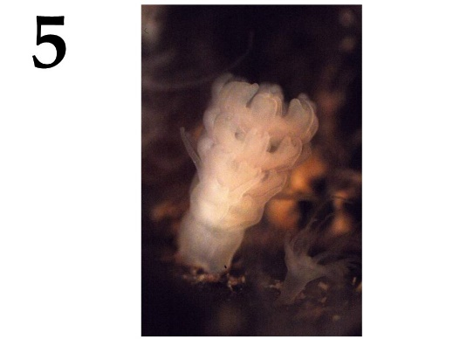

Imaginal forms:
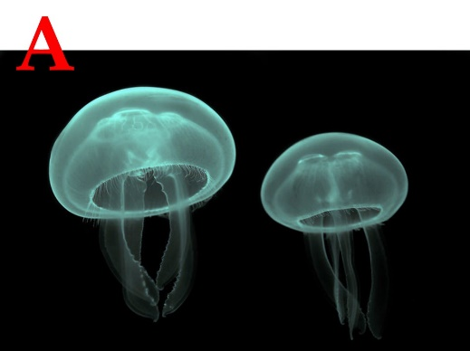 | 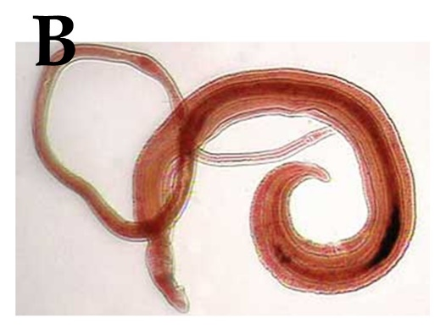 | 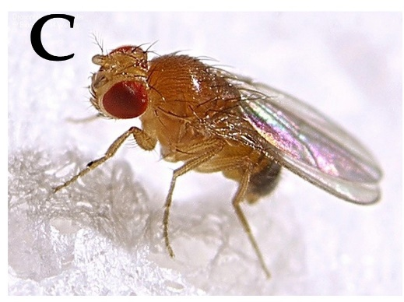
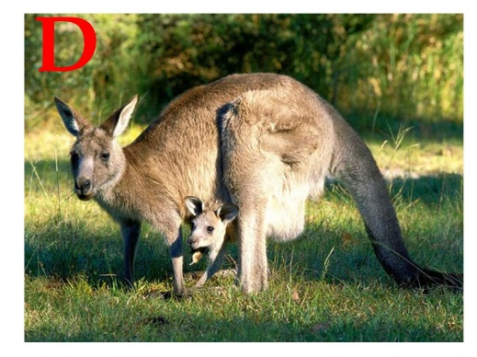 | 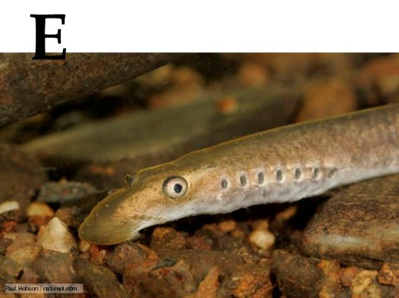

List of juvenile form names (the list is redundant - there are extra names):
- Axolotl;
- Cub;
- Chrysalis;
- Miracidium;
- Nauplius;
- Nymph;
- Sandworm;
- Polyp, strobe;

Task 33 (ID 42) – 5 points
Variant 1
Before the introduction of photography into everyday life, people painted to preserve visual images. Including on a medical topic. Further, there are medical illustrations and works of fine art, displaying directly or in metaphorical form the symptoms of certain diseases, or methods of treatment.
In this task, you will need to match the illustrations with names of diseases and with facts about diseases.

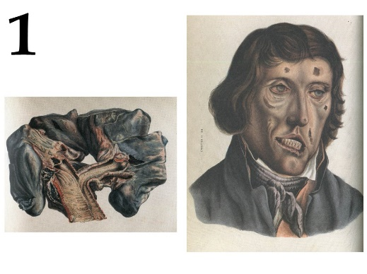 | 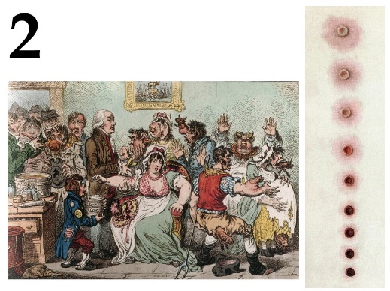 | 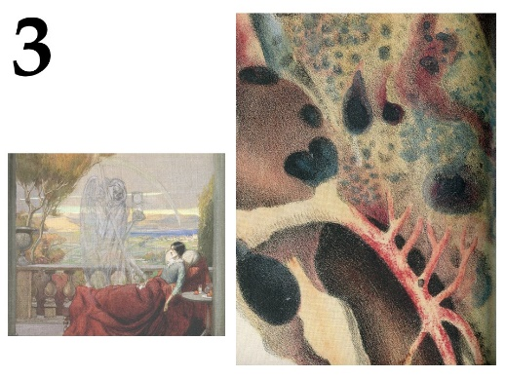
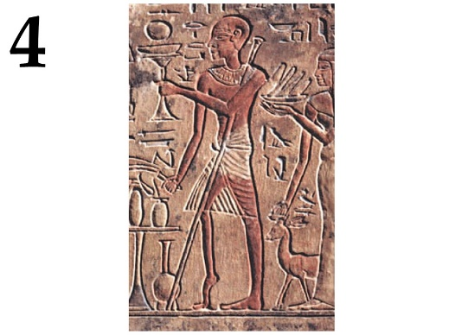 | 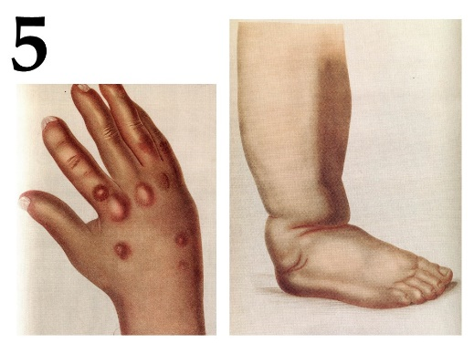

List of diseases (the list is redundant - it contains unnecessary terms):
- Diphtheria;
- Goiter;
- Smallpox;
- Gout;
- Polio;
- Leprosy;
- Syphilis;
- Tuberculosis;
- Scurvy;
- Elephantiasis;

List of Disease Facts:
- Patients used iron lungs to relieve symptoms;
- King Baldwin IV of Jerusalem suffered from this disease;
- From this died: Chekhov, Kafka, Belinsky, Makhno, Oruel, Kustodiev, Chopin, Schrödinger, Spinoza, Jane Austen, Louis XVII and the heroes of literary works "Lady with Camellias", "Three comrades", "Magic Mountain";
- The last case of infection was registered in 1977;
- When it enters the human body, the pathogen settles in the lymph nodes;

Task 33 (ID 42) – 5 points
Variant 2
Before the introduction of photography into everyday life, people painted to preserve visual images. Including on a medical topic. Further, there are medical illustrations and works of fine art, displaying directly or in metaphorical form the symptoms of certain diseases, or methods of treatment.
In this task, you will need to match the illustrations with names of diseases and with facts about diseases.

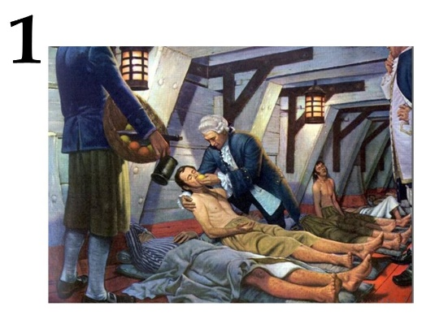 | 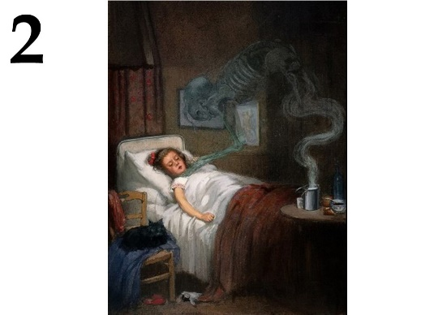 | 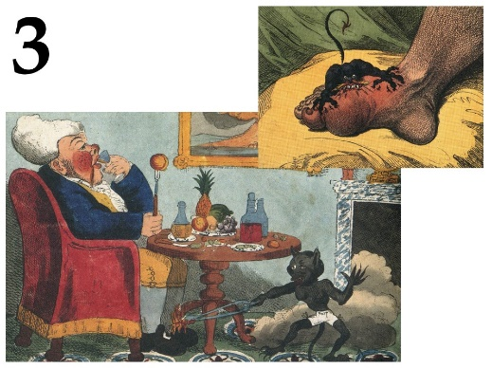
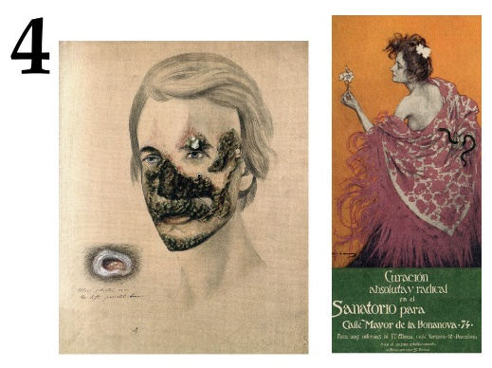 | 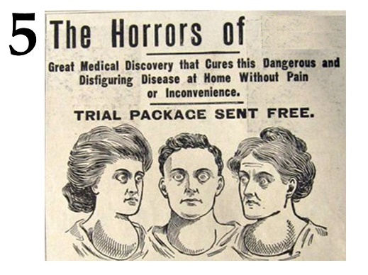

List of diseases (the list is redundant - it contains unnecessary terms):
- Diphtheria;
- Goiter;
- Smallpox;
- Gout;
- Polio;
- Leprosy;
- Syphilis;
- Tuberculosis;
- Scurvy;
- Elephantiasis;

List of Disease Facts:
- The pathogen releases a toxin that inactivates the translation elongation factor eEF-2;
- To prevent this disease, it is recommended to use seaweed, walnuts, persimmon;
- The drug - allopurinol - inhibits xanthine oxidase;
- Pyrotherapy helps against this disease, earlier for this patients were infected with malaria;
- Among mammals, only primates and guinea pigs are susceptible to this disease;

Task 34 (ID 43) – 5 points
Variant 1
The pictures show the chemical formulas of various substances, images of organisms from which they are obtained, as well as images showing the use of this substance in various fields of human activity.
In this task, you need to determine the name of the substance in each of the pictures and compare it with the areas and methods of application given in the list.

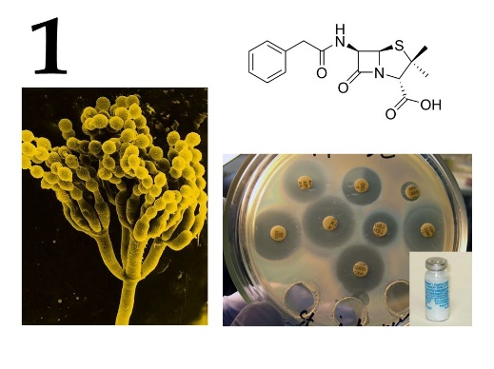 | 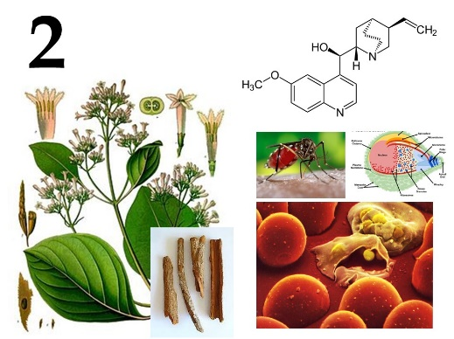 | 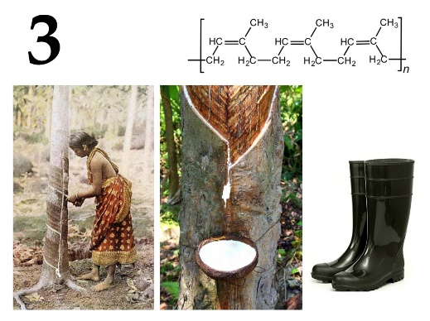
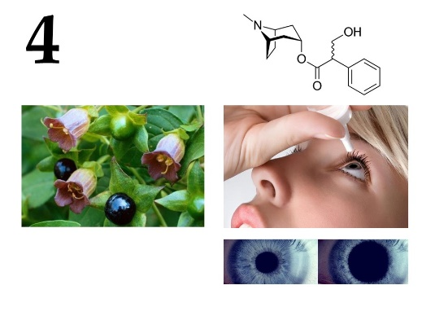 | 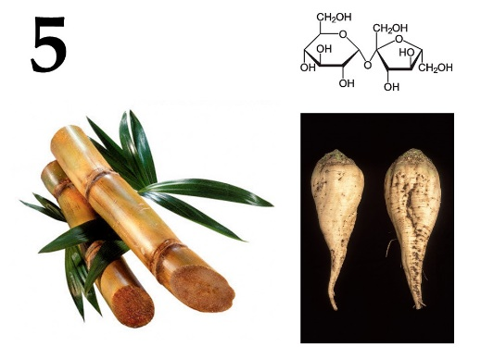

List of names of substances (the list is redundant - it contains unnecessary terms):
- Agarose;
- Atropine;
- Capsaicin;
- Colchicine;
- Caffeine;
- Menthol;
- Penicillin;
- Natural (isoprene) rubber;
- Sucrose;
- Quinine;

List of areas and methods of application of these substances:
- Acetylcholine receptor blocker;
- Waterproof material, good dielectric, natural elastomer;
- Antipyretic, analgesic, antimalarial action;
- Used in the industrial production of edible sugar;
- Cure for bacterial infection;

Task 34 (ID 43) – 5 points
Variant 2
The pictures show the chemical formulas of various substances, images of organisms from which they are obtained, as well as images showing the use of this substance in various fields of human activity.
In this task, you need to determine the name of the substance in each of the pictures and compare it with the areas and methods of application given in the list.

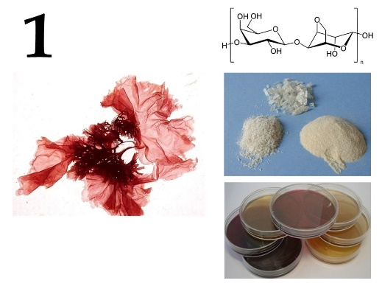 | 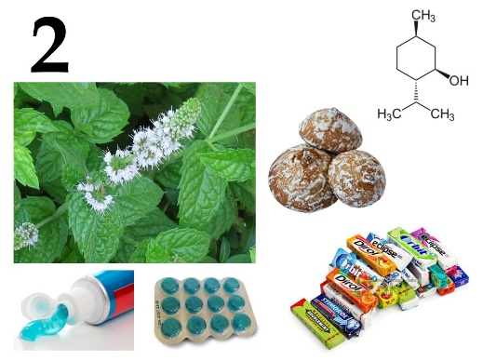 | 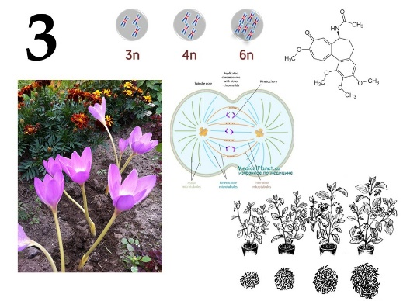
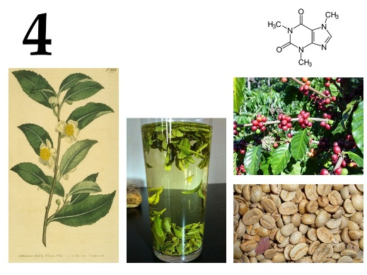 | 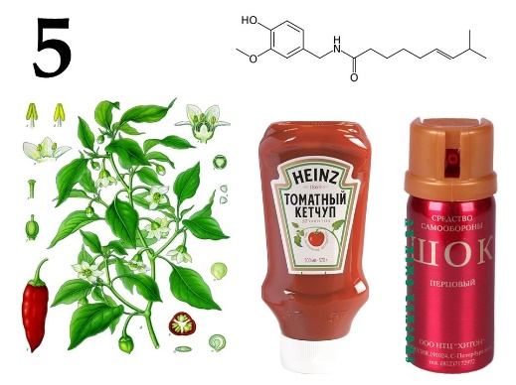

List of names of substances (the list is redundant - it contains unnecessary terms):
- Agarose;
- Atropine;
- Capsaicin;
- Colchicine;
- Caffeine;
- Menthol;
- Penicillin;
- Natural (isoprene) rubber;
- Sucrose;
- Quinine;

List of areas and methods of application of these substances:
- Local anesthetic, stimulates cold receptors, essential nutritional supplement for flavoring;
- Mutagen, blocks the formation of a fission spindle;
- Psychostimulant, essential nutritional supplement;
- Natural irritant, pain reliever;
- Formation of gels, added to the nutrient medium to make it hard;

Task 35 (ID 44) – 5 points
Вариант 1
The cells of multicellular organisms in the process of development and differentiation form a huge variety of tissues. Modern histology distinguishes about 230 different types of human cells, differing in structure and function.
This task contains micrographs of different types of human cells. You need to determine the name of cell type shown in each micrograph and correlate this cell type with a suitable functional characteristic from the list.

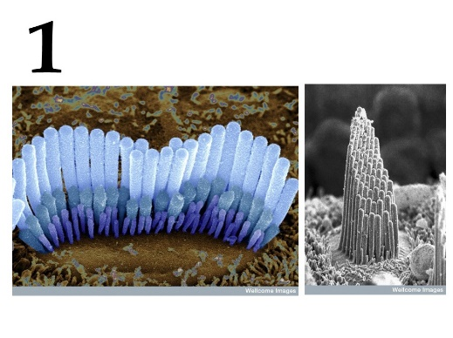 | 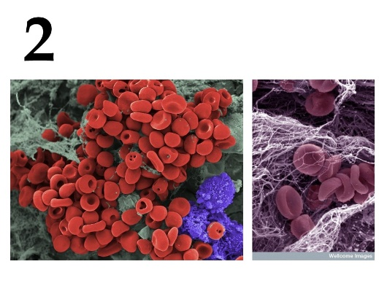 | 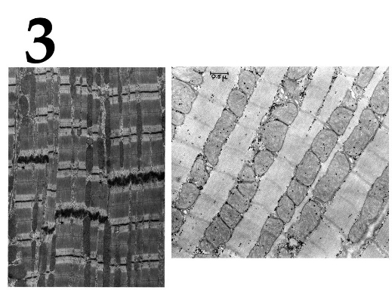
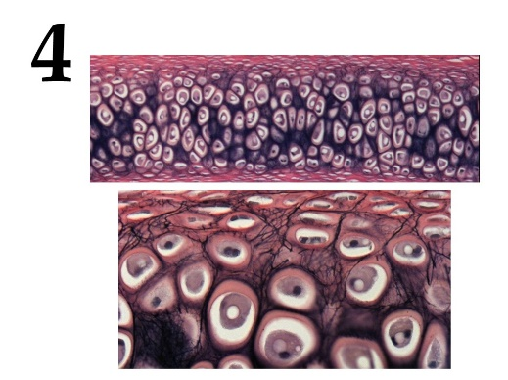 | 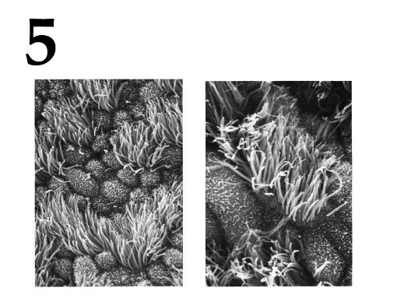

List of cell types (the list is redundant - it contains unnecessary terms):
- Inner ear hair cells;
- Cardiomyocytes;
- Ciliated epithelial cells;
- Macrophages;
- Neurons;
- Rods and cones;
- Sperm;
- Mast cells;
- Chondrocytes;
- Erythrocytes;

Feature list:
- The cells are ectodermal in origin and line the airways. The cells are completely submerged in mucus. The outgrowths of cells perform oscillatory movements and move the mucous membrane along the airways to the external environment;
- The cells are elongated and have longitudinally located myofibrils and myofilaments. Subtypes are distinguished: working (contractile), sinus (pacemaker), transitional, conducting, secretory;
- The main function is the synthesis and isolation of the components of the intercellular substance, which forms an amorphous substance and fibrous structures. By isolating the components of the intercellular substance, these cells walled themselves up in specific cavities – lacunae;
- Very small elastic disc-shaped biconcave cells with a diameter of 7 to 10 microns. They lack the cell nucleus and most organelles, which increases the concentration of hemoglobin;
- They are located in the organ of Corti on a thin basilar membrane in a channel filled with fluid. They got their name from the filaments of stereocilia that are located on the top surface of the cell;

Task 35 (ID 44) – 5 points
Variant 2
The cells of multicellular organisms in the process of development and differentiation form a huge variety of tissues. Modern histology distinguishes about 230 different types of human cells, differing in structure and function.
This task contains micrographs of different types of human cells. You need to determine the name of cell type shown in each micrograph and correlate this cell type with a suitable functional characteristic from the list.

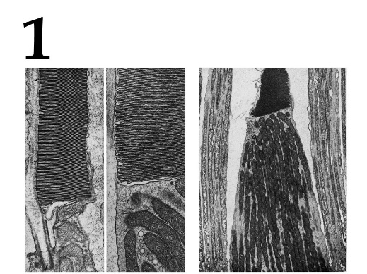 | 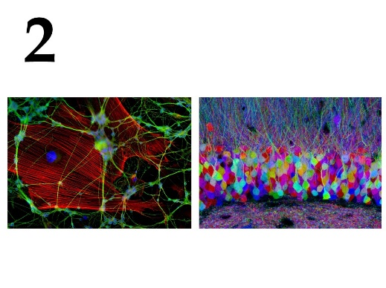 | 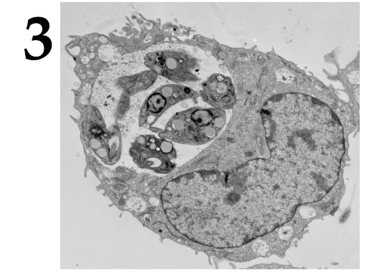
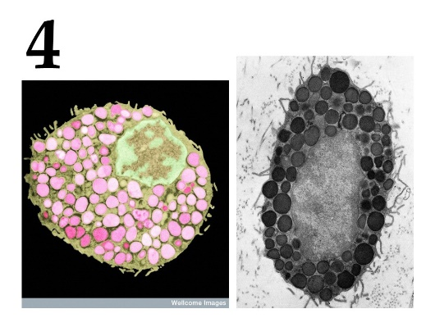 | 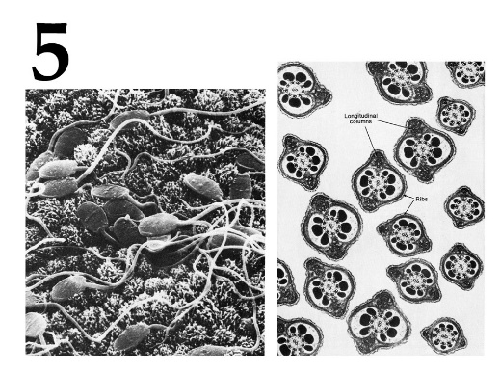

List of cell types (the list is redundant - it contains unnecessary terms):
- Inner ear hair cells;
- Cardiomyocytes;
- Ciliated epithelial cells;
- Macrophages;
- Neurons;
- Rods and cones;
- Sperm;
- Mast cells;
- Chondrocytes;
- Erythrocytes;

Feature list:
- Cells usually have the ability to actively move and serve for fertilization. They usually do not contain a significant amount of cytoplasm and are produced simultaneously in large quantities;
- The cells are contained in the outer granular layer of the retina. Cells respond with hyperpolarization when exposed to light;
- Cells capable of actively capturing and digesting bacteria, the remains of dead cells and other particles that are foreign or toxic to the body. They originate from the erythromyeloid precursors of the yolk sac and embryonic liver or short-lived agranular leukocytes;
- One of the types of granulocytes, which in a mature state are incorporated into connective tissues, are also part of the neuroimmune system. They play an important role in allergic reactions;
- An electrically excitable cell that processes, stores, and transmits information using electrical and chemical signals. The cell contains the nucleus, cell body, and branches;

Task 36 (ID 45) – 5 points
Variant 1
Gene names sometimes reflect the phenotype of individuals with a mutation in a given gene or indicate its function.
The task contains photographs of various living organisms that have some kind of mutant phenotype. You need to match the organisms on photos with phenotypes of the mutation and with genes in which these mutations occurred.

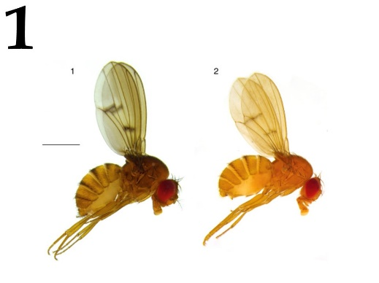 | 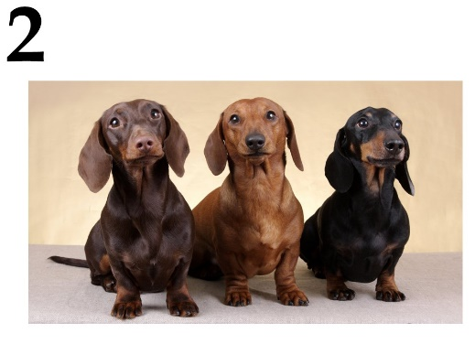 | 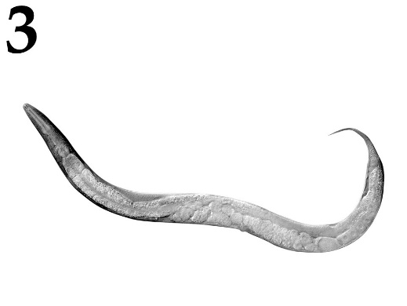
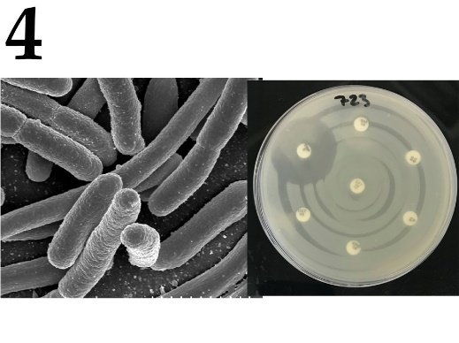 | 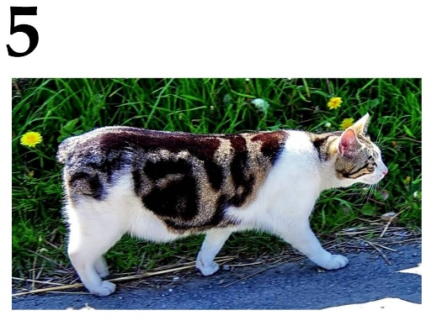

List of phenotypes that appear when certain genes mutated (the list is redundant):
- disrupted melanin synthesis throughout the body;
- yellow cuticle, disrupted melanin distribution;
- tail is very short, lethal in homozygous state;
- impaired synthesis of beta-lactamase, sensitivity to beta-lactam antibiotics;
- impaired blood clotting;
- only amylose is present, amylopectin is absent;
- limbs are short, premature ossification of cartilage;
- violated programmed cell death;

List of genes (list is redundant):
- SBEI (Starch branching enzyme 1);
- Brachiury;
- Tyr (tyrosinase);
- FGF4 (Fibroblast grow factor 4);
- Yellow body;
- F8 (Factor 8);
- Egl-1 (egg laying defective-1);
- AmpC;

Task 36 (ID 45) – 5 points
Variant 2
Gene names sometimes reflect the phenotype of individuals with a mutation in a given gene or indicate its function.
The task contains photographs of various living organisms that have some kind of mutant phenotype. You need to match the organisms on photos with phenotypes of the mutation and with genes in which these mutations occurred.

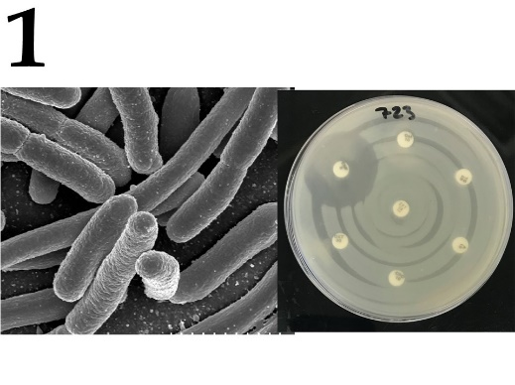 | 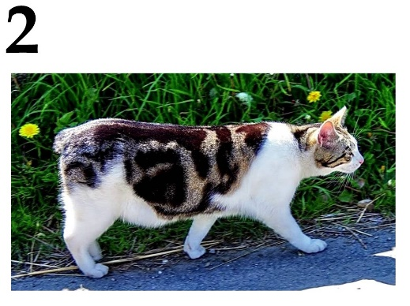 | 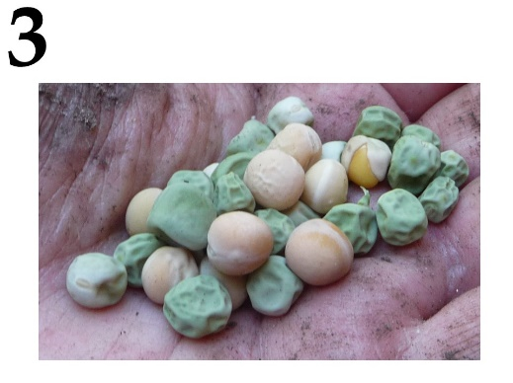
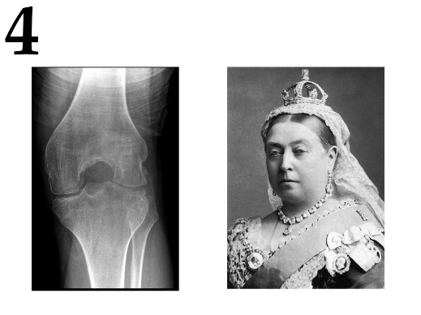 | 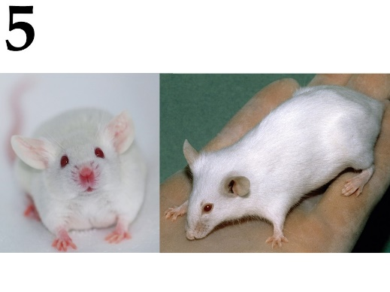

List of phenotypes that appear when certain genes mutated (the list is redundant):
- disrupted melanin synthesis throughout the body;
- yellow cuticle, disrupted melanin distribution;
- tail is very short, lethal in homozygous state;
- impaired synthesis of beta-lactamase, sensitivity to beta-lactam antibiotics;
- impaired blood clotting;
- only amylose is present, amylopectin is absent;
- limbs are short, premature ossification of cartilage;
- violated programmed cell death;

List of genes (list is redundant):
- SBEI (Starch branching enzyme 1);
- Brachiury;
- Tyr (tyrosinase);
- FGF4 (Fibroblast grow factor 4);
- Yellow body;
- F8 (Factor 8);
- Egl-1 (egg laying defective-1);
- AmpC;

Task 37 (ID 46) – 5 points
Variant 1
The task contains five illustrations of ancient animals, each of which is of great importance for the reconstruction of the evolutionary paths of vertebrates.
In this task, for each animal you need to indicate its name and geochronological period of life.

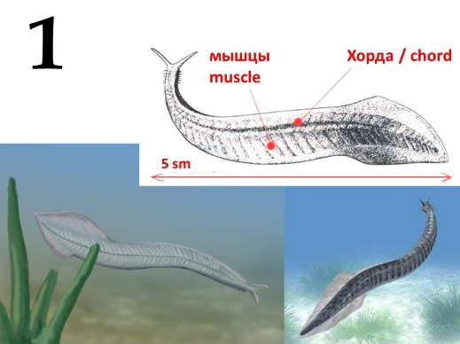 | 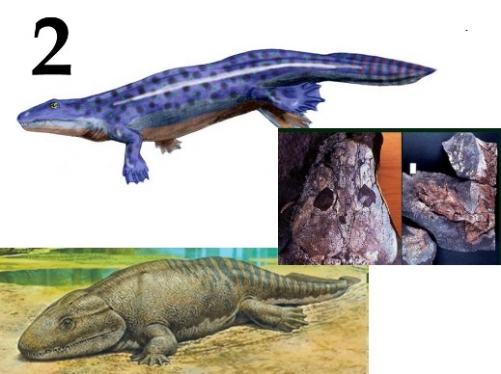 | 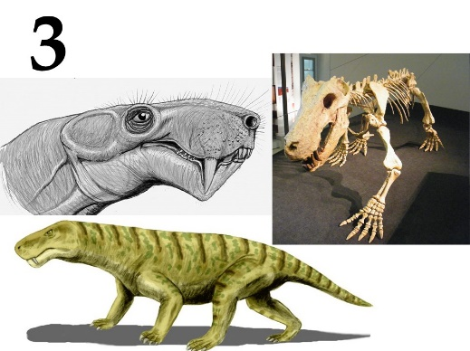
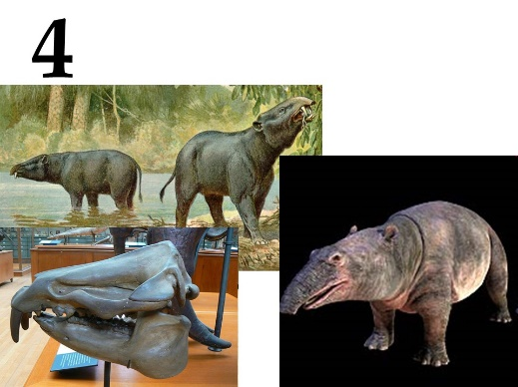 | 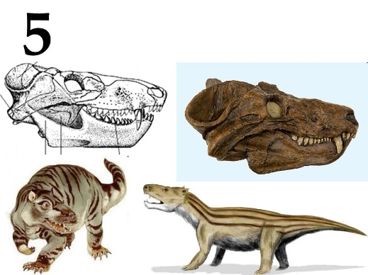

List of animal names (the list is redundant - it contains unnecessary terms):
- Archaeopteryx lithographica;
- Inostrancevia alexandri;
- Ichthyostega stensioei;
- Moeritherium lyonsi;
- Pikaia gracilens;
- Protoavis texensis;
- Proconsul africanus;
- Cynognathus crateronotus;

List of geological periods (the list is redundant):
- Devonian;
- Cambrian;
- Neogene;
- Paleogene;
- Permian;
- Triassic;
- Jurassic;

Task 37 (ID 46) – 5 points
Variant 2
The task contains five illustrations of ancient animals, each of which is of great importance for the reconstruction of the evolutionary paths of vertebrates.
In this task, for each animal you need to indicate its name and geochronological period of life.

 |  | 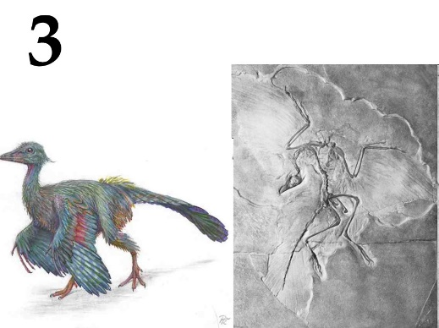
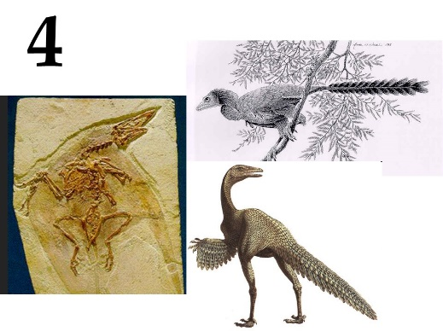 | 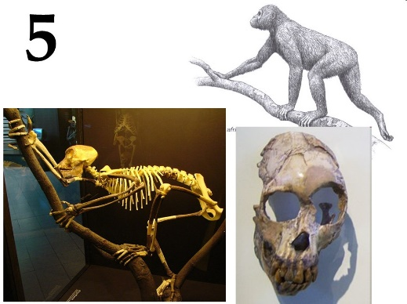

List of animal names (the list is redundant - it contains unnecessary terms):
- Archaeopteryx lithographica;
- Inostrancevia alexandri;
- Ichthyostega stensioei;
- Moeritherium lyonsi;
- Pikaia gracilens;
- Protoavis texensis;
- Proconsul africanus;
- Cynognathus crateronotus;

List of geological periods (the list is redundant):
- Devonian;
- Cambrian;
- Neogene;
- Paleogene;
- Permian;
- Triassic;
- Jurassic;

